**PRACTICAL - 1**

**AIM**: Perform 5 different types of (port) scanning using nmap on a single port and capture the packets using wireshark and analyze the output.

**TOOL INTRODUCTION:**

1. Nmap –

* Nmap is a free and open-source network scanner created by Gordon Lyon. Nmap is used to discover hosts and services on a computer network by sending packets and analyzing the responses.
* Nmap provides a number of features for probing computer networks, including host discovery and service and operating system detection.
* These features are extensible by scripts that provide more advanced service detection, vulnerability detection, and other features.
* Nmap can adapt to network conditions including latency and congestion during a scan.
* Nmap started as a Linux utility and was ported to other systems including Windows, macOS, and BSD. It is most popular on Linux, followed by Windows.

1. Wireshark –

* Wireshark is a free and open-source packet analyzer.
* It is used for network troubleshooting, analysis, software and communications protocol development, and education.
* Originally named Ethereal, the project was renamed Wireshark in May 2006 due to trademark issues.
* Wireshark is cross-platform, using the Qt widget toolkit in current releases to implement its user interface, and using pcap to capture packets; it runs on Linux, macOS, BSD, Solaris, some other Unix-like operating systems, and Microsoft Windows.
* There is also a terminal-based (non-GUI) version called TShark. Wireshark, and the other programs distributed with it such as TShark, are free software, released under the terms of version 2 of the GNU General Public License.

**Port Scanning:**

1. **Host discovery / ping scan**

* Ping scan in nmap is done to check if the target host is alive or not.
* As we know that ping by default send the ICMP echo request and gets an ICMP echo reply if the system is alive.
* Command – nmap –sn ip, domain name, ip range, subnet -172.16.1.1/24
* Ex: nmap –sn 8.8.8.8

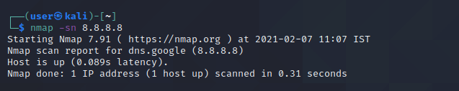

1. **Default Scan - nmap ip**

* By default, Nmap scans the most common 1,000 ports for each protocol.
* This option specifies which ports you want to scan and overrides the default. Individual port numbers are OK, as are ranges separated by a hyphen (e.g.1-1023).
* Command – nmap ip
* Ex: nmap 8.8.8.8

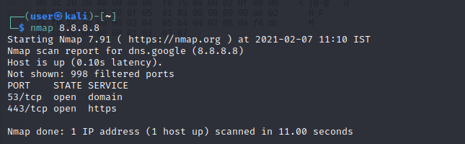

* Filter – tcp.port ==135

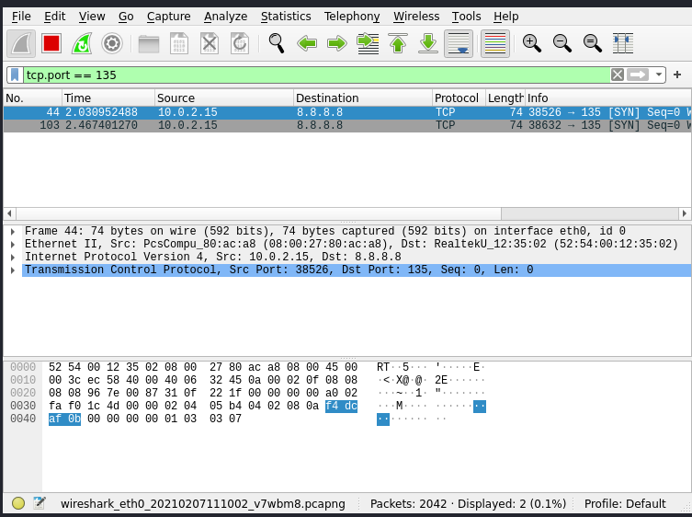

* By default, Nmap performs a SYN Scan, though it substitutes a connect scan if the user does not have proper privileges to send raw packets (requires root access on Unix).

1. **TCP SYN Scan**

* SYN scan is the default and most popular scan option for good reasons. It can be performed quickly, scanning thousands of ports per second on a fast network not hampered by restrictive firewalls.
* It is also relatively unobtrusive and stealthy since it never completes TCP connections.
* SYN scan works against any compliant TCP stack rather than depending on idiosyncrasies of specific platforms as Nmap's FIN/NULL/Xmas, Maimon and idle scans do.
* It also allows clear, reliable differentiation between the open, closed, and filtered states.
  + Command: nmap -sS ip
  + Ex: nmap -sS 8.8.8.8

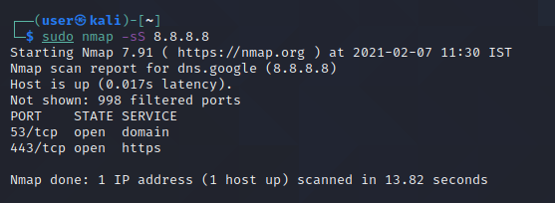

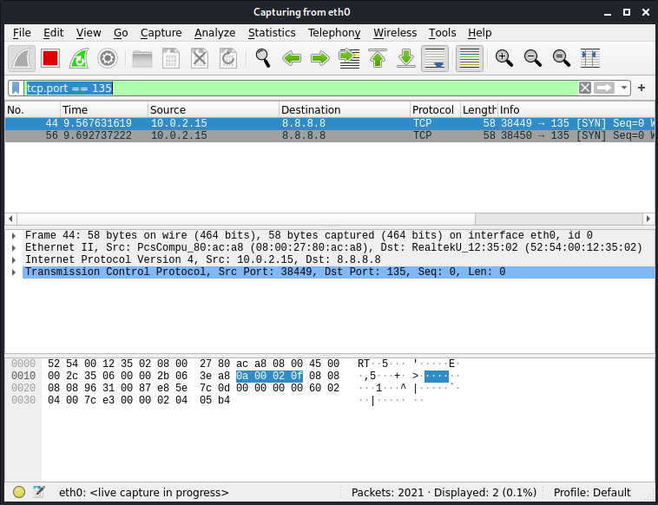

* You send a SYN packet, as if you are going to open a real connection and then wait for a response. A SYN/ACK indicates the port is listening (open), while a RST (reset) is indicative of a non-listener.
* If no response is received after several retransmissions, the port is marked as filtered.
* The port is also marked filtered if an ICMP unreachable error (type 3, code 0, 1, 2, 3, 9, 10, or 13) is received. The port is also considered open if a SYN packet (without the ACK flag) is received in response.

1. **TCP Connect Scan**

* TCP connect scan is the default TCP scan type when SYN scan is not an option. This is the case when a user does not have raw packet privileges.
* Instead of writing raw packets as most other scan types do, Nmap asks the underlying operating system to establish a connection with the target machine and port by issuing the connect system call.
* This is the same high-level system call that web browsers, P2P clients, and most other network-enabled applications use to establish a connection.
* It is part of a programming interface known as the Berkeley Sockets API.
* Rather than read raw packet responses off the wire, Nmap uses this API to obtain status information on each connection attempt.
  + Command: nmap -sT ip
  + 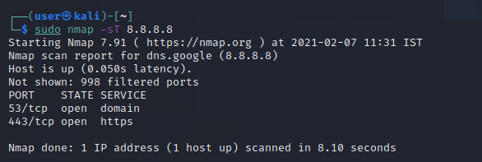Ex: nmap -sT 8.8.8.8

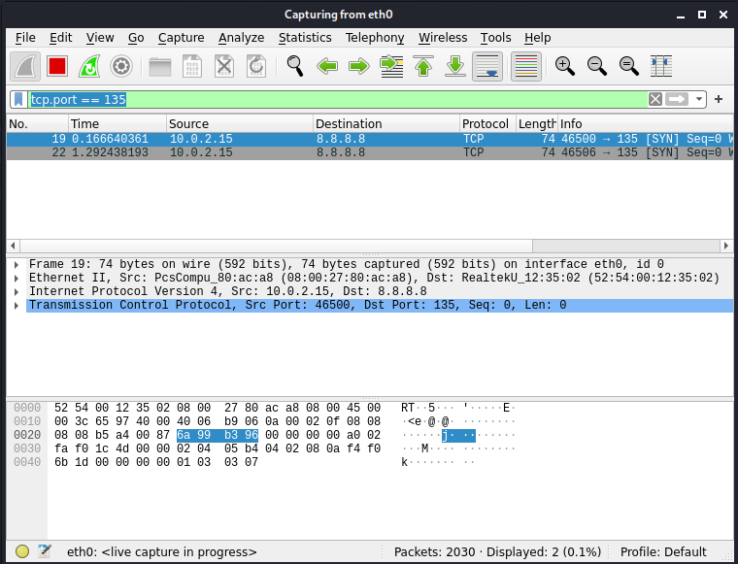

* The system call completes connections to open target ports rather than performing the half-open reset that SYN scan does.
* Not only does this take longer and require more packets to obtain the same information, but target machines are more likely to log the connection.

1. **UDP Scan**

* While most popular services on the Internet run over the TCP protocol, UDP services are widely deployed.
* DNS, SNMP, and DHCP (registered ports 53, 161/162, and 67/68) are three of the most common.
* Because UDP scanning is generally slower and more difficult than TCP, some security auditors ignore these ports.
* This is a mistake, as exploitable UDP services are quite common and attackers certainly don't ignore the whole protocol.
* Fortunately, Nmap can help inventory UDP ports.
  + Command: nmap -sU ip
  + Ex: nmap -sU 8.8.8.8

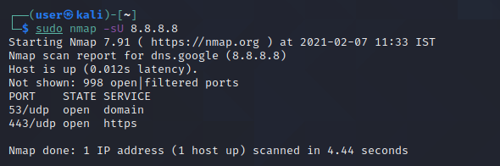

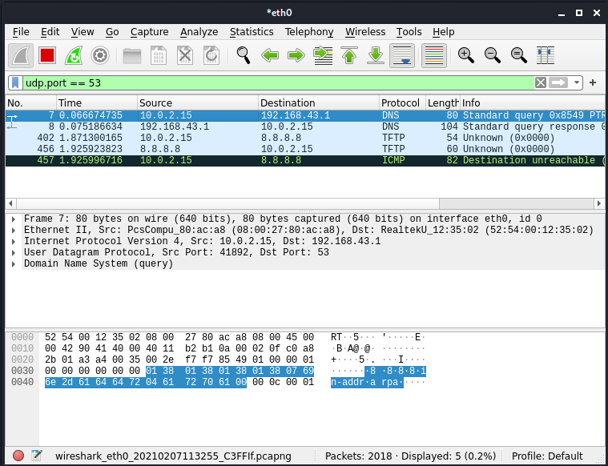

* UDP scan works by sending a UDP packet to every targeted port. For some common ports such as 53 and 161, a protocol-specific payload is sent to increase response rate, but for most ports the packet is empty unless the --data, --data-string, or --data-length options are specified.
* If an ICMP port unreachable error (type 3, code 3) is returned, the port is closed. Other ICMP unreachable errors (type 3, codes 0, 1, 2, 9, 10, or 13) mark the port as filtered. Occasionally, a service will respond with a UDP packet, proving that it is open.
* If no response is received after retransmissions, the port is classified as open|filtered.
* This means that the port could be open, or perhaps packet filters are blocking the communication.

1. **TCP null, TCP Xmas, TCP FIN**

* These three scan types (even more are possible with the --scanflags option described in the next section) exploit a subtle loophole in the TCP RFC to differentiate between open and closed ports.
* Page 65 of RFC 793 says that “if the [destination] port state is CLOSED .... an incoming segment not containing a RST causes a RST to be sent in response.”
* Then the next page discusses packets sent to open ports without the SYN, RST, or ACK bits set, stating that: “you are unlikely to get here, but if you do, drop the segment, and return.”
* When scanning systems compliant with this RFC text, any packet not containing SYN, RST, or ACK bits will result in a returned RST if the port is closed and no response at all if the port is open.
* As long as none of those three bits are included, any combination of the other three (FIN, PSH, and URG) are OK.
  + Command:
    1. TCP null: nmap -sN ip
    2. TCP Xmas: nmap -sX ip
    3. TCP FIN: nmap -sF ip
  + Ex:
    1. TCP null: nmap -sN 8.8.8.8
    2. TCP Xmas: nmap -sX 8.8.8.8
    3. TCP FIN: nmap -sF 8.8.8.8
  + TCP null:

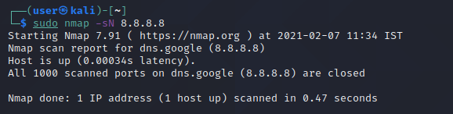

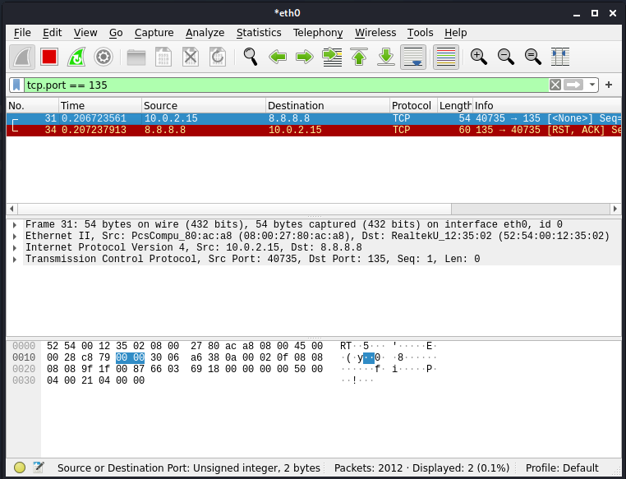

* TCP Xmas:

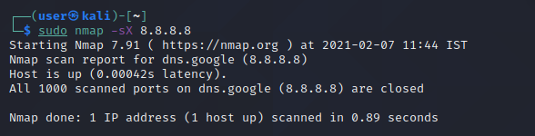

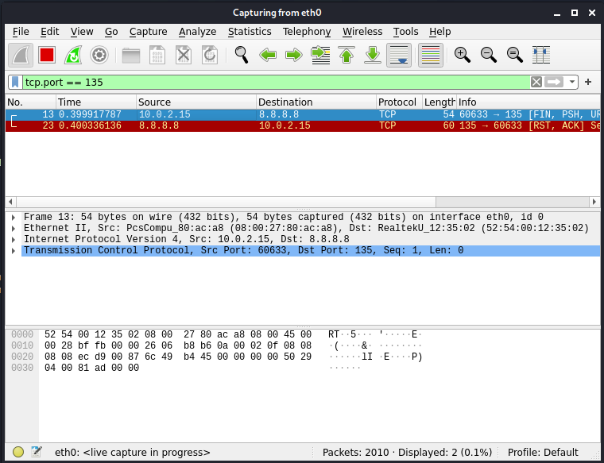

* TCP FIN:

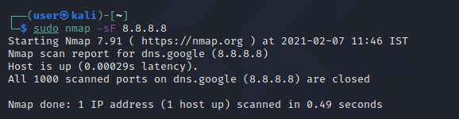

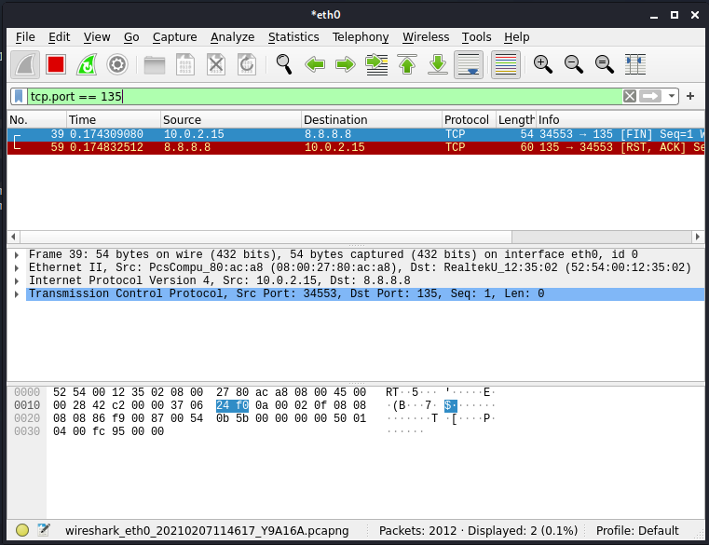

* These three scan types are exactly the same in behavior except for the TCP flags set in probe packets.
* If a RST packet is received, the port is considered closed, while no response means it is open|filtered.
* The port is marked filtered if an ICMP unreachable error (type 3, code 0, 1, 2, 3, 9, 10, or 13) is received.

1. **TCP ACK**

* This scan is different than the others discussed so far in that it never determines open (or even open|filtered) ports.
* It is used to map out firewall rulesets, determining whether they are stateful or not and which ports are filtered.
  + Command: nmap -sA ip
  + Ex: nmap -sA 8.8.8.8

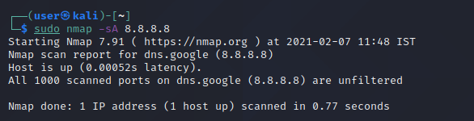

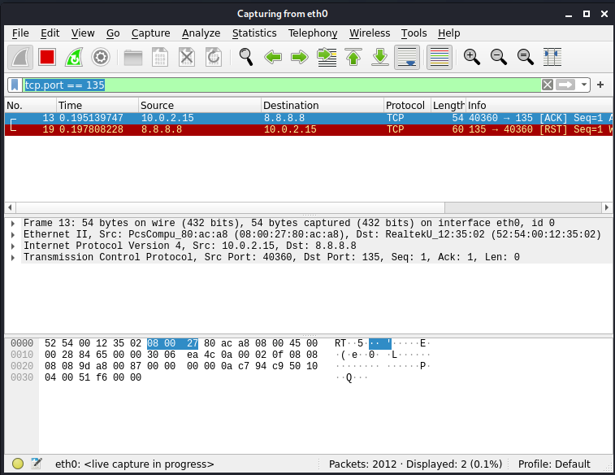

* The ACK scan probe packet has only the ACK flag set (unless you use --scanflags). When scanning unfiltered systems, open and closed ports will both return a RST packet.
* Nmap then labels them as unfiltered, meaning that they are reachable by the ACK packet, but whether they are open or closed is undetermined.
* Ports that don't respond, or send certain ICMP error messages back (type 3, code 0, 1, 2, 3, 9, 10, or 13), are labeled filtered.

1. **TCP window**

* Window scan is exactly the same as ACK scan except that it exploits an implementation detail of certain systems to differentiate open ports from closed ones, rather than always printing unfiltered when a RST is returned.
* It does this by examining the TCP Window field of the RST packets returned. On some systems, open ports use a positive window size (even for RST packets) while closed ones have a zero window.
* So instead of always listing a port as unfiltered when it receives a RST back, Window scan lists the port as open or closed if the TCP Window value in that reset is positive or zero, respectively.
  + Command: nmap -sW ip
  + Ex: nmap -sW 8.8.8.8

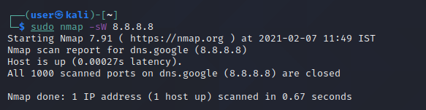

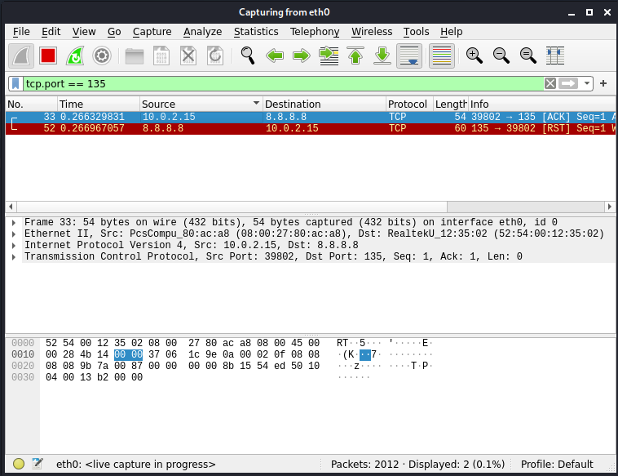

* This scan relies on an implementation detail of a minority of systems out on the Internet, so you can't always trust it.
* Systems that don't support it will usually return all ports closed. Of course, it is possible that the machine really has no open ports.
* If most scanned ports are closed but a few common port numbers (such as 22, 25, 53) are filtered, the system is most likely susceptible.
* Occasionally, systems will even show the exact opposite behavior.
* If your scan shows 1,000 open ports and three closed or filtered ports, then those three may very well be the truly open ones.

1. **TCP PSH**

* Truly advanced Nmap users need not limit themselves to the canned scan types offered. The --scanflags option allows you to design your own scan by specifying arbitrary TCP flags.
* Let your creative juices flow, while evading intrusion detection systems whose vendors simply paged through the Nmap man page adding specific rules!
* The --scanflags argument can be a numerical flag value such as 9 (PSH and FIN), but using symbolic names is easier.
* Just mash together any combination of URG, ACK, PSH, RST, SYN, and FIN. For example, --scanflags URGACKPSHRSTSYNFIN sets everything, though it's not very useful for scanning.
* The order these are specified in is irrelevant.
  + Command: nmap -scanflags flag ip
  + Ex: nmap -scanflags “PSH” ip

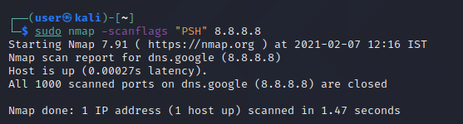

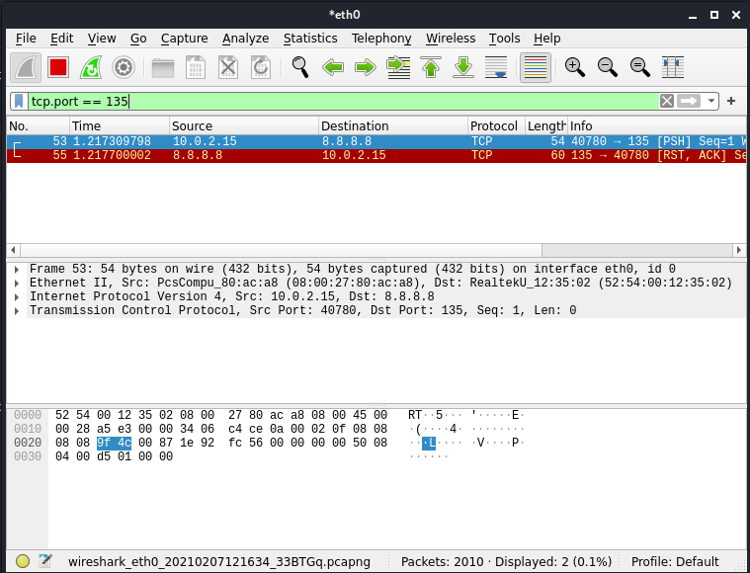

* a SYN scan considers no-response to indicate a filtered port, while a FIN scan treats the same as open|filtered.

1. **Other Options : -p, -p*, -p0- , -T, -A, -v, -d** 
   * **-p:**
     1. This option specifies which ports you want to scan and overrides the default. Individual port numbers are OK, as are ranges separated by a hyphen (e.g. 1-1023).
     2. The beginning and/or end values of a range may be omitted, causing Nmap to use 1 and 65535, respectively.
     3. So you can specify -p- to scan ports from 1 through 65535. Scanning port zero is allowed if you specify it explicitly.
     4. For IP protocol scanning (-sO), this option specifies the protocol numbers you wish to scan for (0–255).

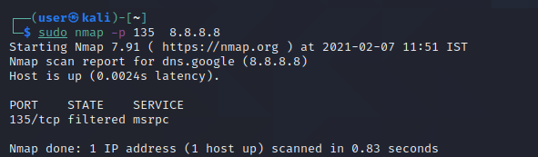

* + **-p*:**
    1. This option will scan all the reachable ports of the target.

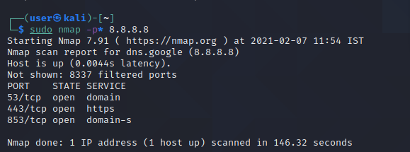

* + **-PO:**
    1. One of the newer host discovery options is the IP protocol ping, which sends IP packets with the specified protocol number set in their IP header.
    2. The protocol list takes the same format as do port lists in the previously discussed TCP, UDP and SCTP host discovery options.
    3. If no protocols are specified, the default is to send multiple IP packets for ICMP (protocol 1), IGMP (protocol 2), and IP-in-IP (protocol 4). The default protocols can be configured at compile-time by changing DEFAULT_PROTO_PROBE_PORT_SPEC in nmap.h.
    4. Note that for the ICMP, IGMP, TCP (protocol 6), UDP (protocol 17) and SCTP (protocol 132), the packets are sent with the proper protocol headers while other protocols are sent with no additional data beyond the IP header (unless any of --data, --data-string, or --data-length options are specified).

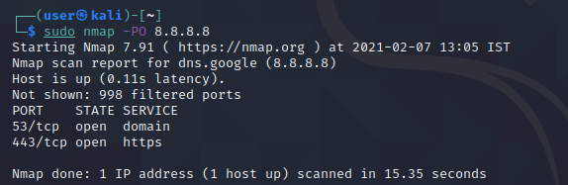

* + **-T:**
    1. While the fine-grained timing controls discussed in the previous section are powerful and effective, some people find them confusing.
    2. Moreover, choosing the appropriate values can sometimes take more time than the scan you are trying to optimize.
    3. Fortunately, Nmap offers a simpler approach, with six timing templates. You can specify them with the -T option and their number (0–5) or their name. The template names are paranoid (0), sneaky (1), polite (2), normal (3), aggressive (4), and insane (5).
    4. The first two are for IDS evasion. Polite mode slows down the scan to use less bandwidth and target machine resources. Normal mode is the default and so -T3 does nothing.
    5. Aggressive mode speeds scans up by making the assumption that you are on a reasonably fast and reliable network.
    6. Finally insane mode assumes that you are on an extraordinarily fast network or are willing to sacrifice some accuracy for speed.

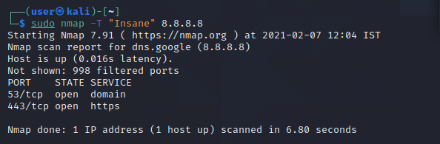

* + **-A:**
    1. This option enables additional advanced and aggressive options. Presently this enables OS detection (-O), version scanning (-sV), script scanning (-sC) and traceroute (--traceroute).
    2. More features may be added in the future. The point is to enable a comprehensive set of scan options without people having to remember a large set of flags.
    3. However, because script scanning with the default set is considered intrusive, you should not use -A against target networks without permission.
    4. This option only enables features, and not timing options (such as -T4) or verbosity options (-v) that you might want as well.
    5. Options which require privileges (e.g. root access) such as OS detection and traceroute will only be enabled if those privileges are available.

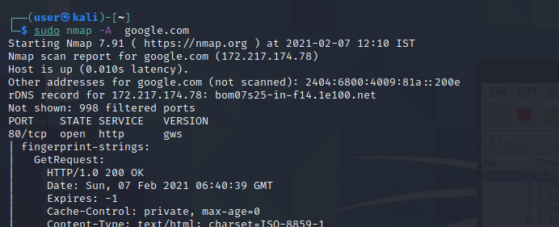

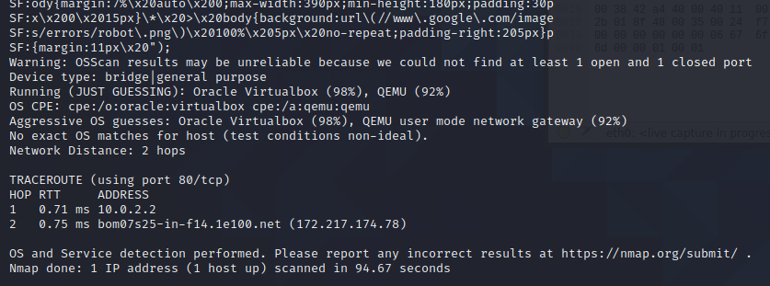

* + **-v:**
    1. Increases the verbosity level, causing Nmap to print more information about the scan in progress.
    2. Open ports are shown as they are found and completion time estimates are provided when Nmap thinks a scan will take more than a few minutes.
    3. Use it twice or more for even greater verbosity: -vv, or give a verbosity level directly, for example -v3.

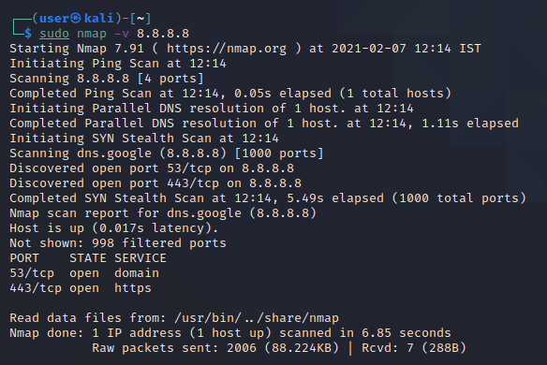

* + -**d**:
    1. When even verbose mode doesn't provide sufficient data for you, debugging is available to flood you with much more!
    2. As with the verbosity option (-v), debugging is enabled with a command-line flag (-d) and the debug level can be increased by specifying it multiple times, as in -dd, or by setting a level directly.
    3. For example, -d9 sets level nine. That is the highest effective level and will produce thousands of lines unless you run a very simple scan with very few ports and targets.

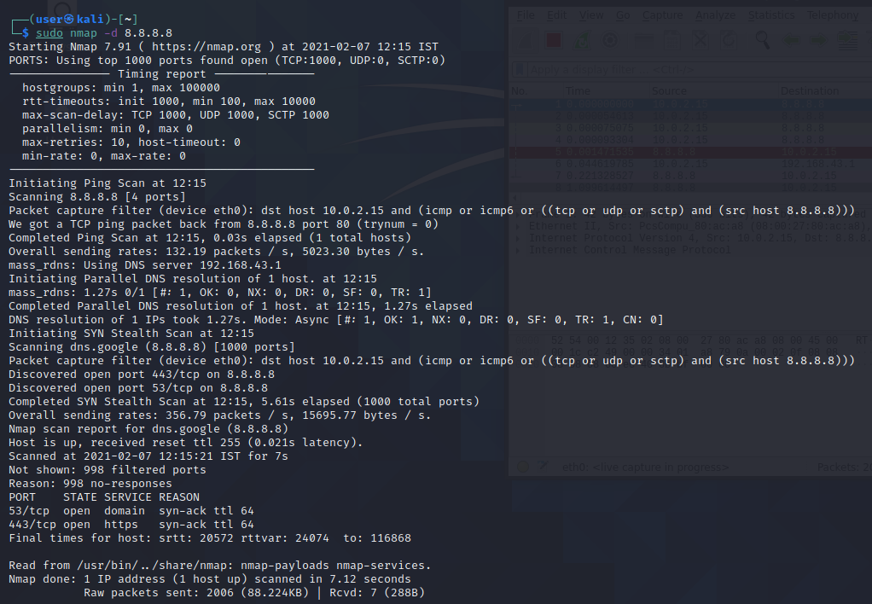

**CONCLUSION:**

In this practical, we learned about NMAP and different scans. We performed different kind of scans on certain websites and analyzed the output using Wireshark by checking on transferred packets.

**PRACTICAL - 2**

**AIM**:

1. Perform Port Scanning, File Transfer, Client-server chat and Basic Webserver implementation using netcat.
2. Find the service running on the particular port using netcat.

**TOOL INTRODUCTION:**

**NetCat** –

* netcat (often abbreviated to nc) is a computer networking utility for reading from and writing to network connections using TCP or UDP.
* The command is designed to be a dependable back-end that can be used directly or easily driven by other programs and scripts.
* At the same time, it is a feature-rich network debugging and investigation tool, since it can produce almost any kind of connection its user could need and has a number of built-in capabilities.
* Its list of features includes port scanning, transferring files, and port listening, and it can be used as a backdoor.
* The original netcat's features include:
  + 1. Outbound or inbound connections, TCP or UDP, to or from any ports
    2. Full DNS forward/reverse checking, with appropriate warnings
    3. Ability to use any local source port
    4. Ability to use any locally configured network source address
    5. Built-in port-scanning capabilities, with randomization
    6. Built-in loose source-routing capability
    7. Can read command line arguments from standard input
    8. Slow-send mode, one line every N seconds
    9. Hex dump of transmitted and received data
    10. Optional ability to let another program service establish connections
    11. Optional telnet-options responder

**Port Scanning:**

* This may useful to know which ports are open and running services on a target machine.
* Try the nc / netcat command as follow.
* The -z flag can be used to tell nc to report open ports, rather than initiate a connection.
* You need to specify hostname / ip along with the port range to limit and speedup operation:
* Command: nc -z -v hostname port-range
* Ex: nc -z -v localhost 80

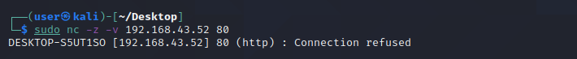

**File Transfer:**

* The nc ( netcat ) command can be used to transfer arbitrary data over the network.
* It represents a quick way for Linux administrators to transfer data without the need for an additional data transfer services such as FTP, HTTP, SCP etc.
* This config will show you an example on how to transfer data between to network hosts.
* We will be transferring data myfile.txt file from a localhost to a destination host with an IP address 10.1.1.2.
* Command (Transmitter): nc -v -l -p port < filename
* Command (Reciever): nc -v hostname port > filename
* Ex (Transmitter): nc -v -l -p 36180 < hello.txt
* Ex (Receiver): nc -v localhost 36180 > hello.txt

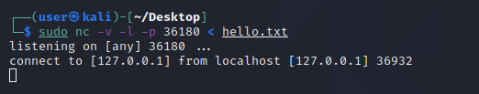

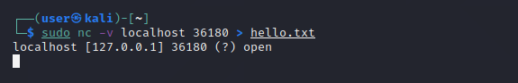

**Client-Server Chat:**

* To create a simple chat we need two instances of netcat, one to listen for incoming connections (the server) and another one to start the connection.
  + Command (Server): nc -l -p port
  + Command (Client): nc hostname port
  + Ex (Server): nc -l -p 36180
  + Ex (Client) : nc localhost 36180

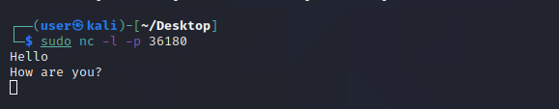

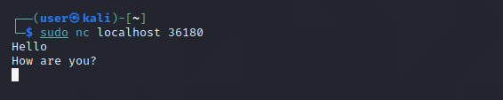

**Basic Webserver Implementation:**

* The netcat tool nc can operate as a TCP client. Because HTTP works over TCP, nc can be used as an HTTP server!
* Because nc is a UNIX tool, we can use it to make custom web servers: servers which return any HTTP headers you want, servers which return the response very slowly, servers which return invalid HTTP, etc.
* You can also use nc as a quick-and-dirty static file server.
  + Command: nc -l -p 8000
  + Ex: nc -l -p 8000

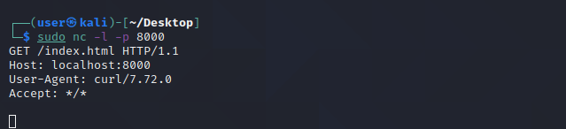

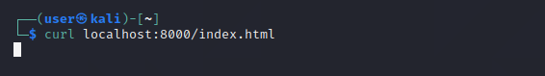

* After we start listening on port 8000, we can use command “curl localhost:8000/index.html” to send request on port 8000 on localserver.
* We can confirm that by looking at response in server side where GET request will be reflected.

**CONCLUSION:**

In this practical, we learned about NetCat which has many functionality and it is easy to use tool. We first transferred a file using nc and then implemented a chat server. We also implemented basic web server with single command.

**PRACTICAL - 3**

**AIM**:

Use Wireshark and netsniff to perform Cryptanalytic attacks using packet sniffing.

**TOOL INTRODUCTION:**

**Netsniff:**

* + Netsniff-ng is a fast, minimal tool to analyze network packets, capture pcap files, replay pcap files, and redirect traffic between interfaces with the help of zero-copy packet(7) sockets.
  + Netsniff-ng uses both Linux specific RX_RING and TX_RING interfaces to perform zero-copy.
  + This is to avoid copy and system call overhead between kernel and user address space.
  + When we started working on netsniff-ng, the pcap(3) library did not use this zero-copy facility.
  + Netsniff-ng is Linux specific, meaning there is no support for other operating systems.
  + Therefore we can keep the code footprint quite minimal and to the point. Linux packet sockets and its RX_RING and TX_RING interfaces bypass the normal packet processing path through the networking stack.
  + This is the fastest capturing or transmission performance one can get from user space out of the box, without having to load unsupported or non-mainline third-party kernel modules.
  + We explicitly refuse to build netsniff-ng on top of ntop/PF_RING. Not because we do not like it (we do find it interesting), but because of the fact that it is not part of the mainline kernel.
  + Therefore, the ntop project has to maintain and sync out-of-tree drivers to adapt them to their DNA.
  + Eventually, we went for untainted Linux kernel, since its code has a higher rate of review, maintenance, security and bug fixes.
  + Netsniff-ng also supports early packet filtering in the kernel.
  + It has support for low-level and high-level packet filters that are translated into Berkeley Packet Filter instructions.
  + Netsniff-ng can capture pcap files in several different pcap formats that are interoperable with other tools.
  + The following pcap I/O methods are supported for efficient to-disc capturing: scatter-gather, mmap, read, and write.
  + Netsniff-ng is also able to rotate pcap files based on data size or time intervals, thus, making it a useful backend tool for subsequent traffic analysis.

**Netsniff:**

We can use netsniff-ng command to access netsniff tool.

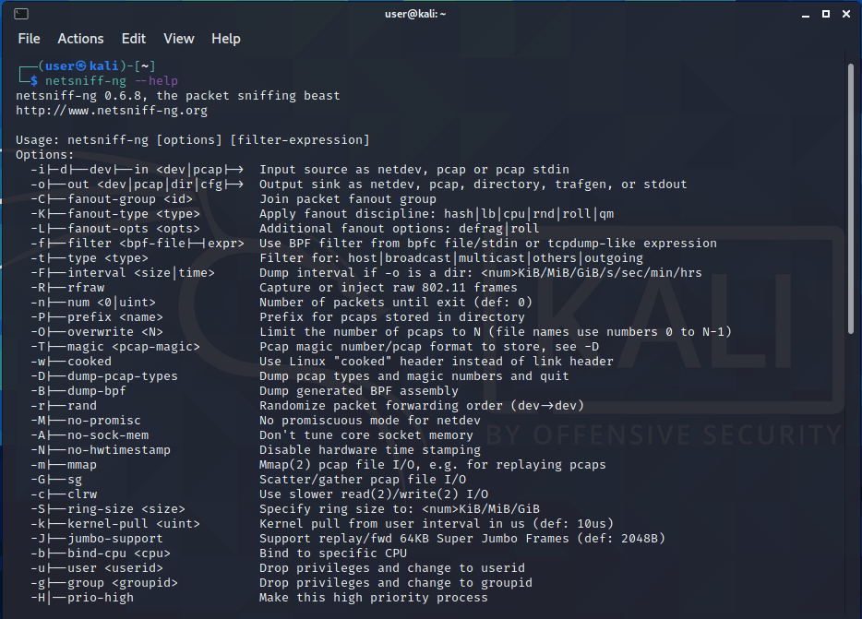

Command: netsniff-ng -D

We can see all magic codes by this command with respective features.

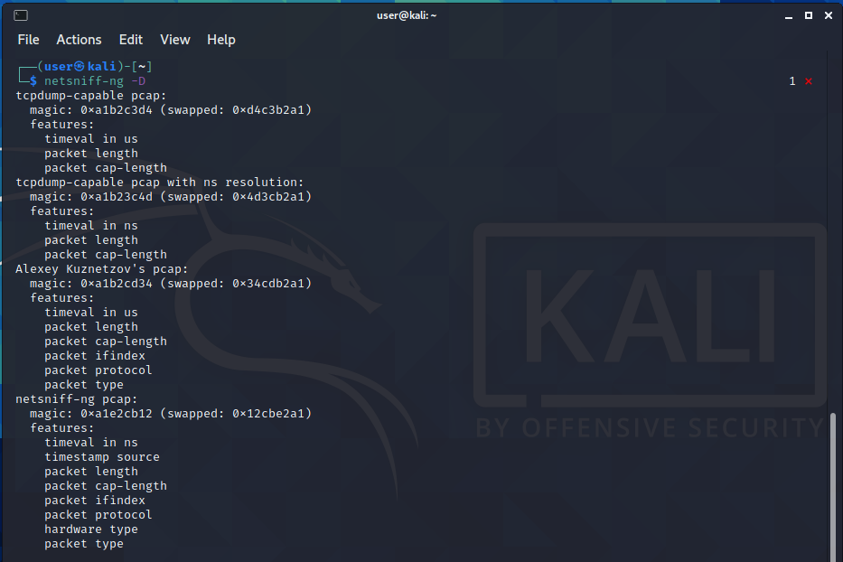

We can sniff packets from netsniff by using these magic codes.

Command: sudo netsniff-ng –in eth0 –out filename.pcap -T 0xa1e2cb12 -b 0 tcp or udp

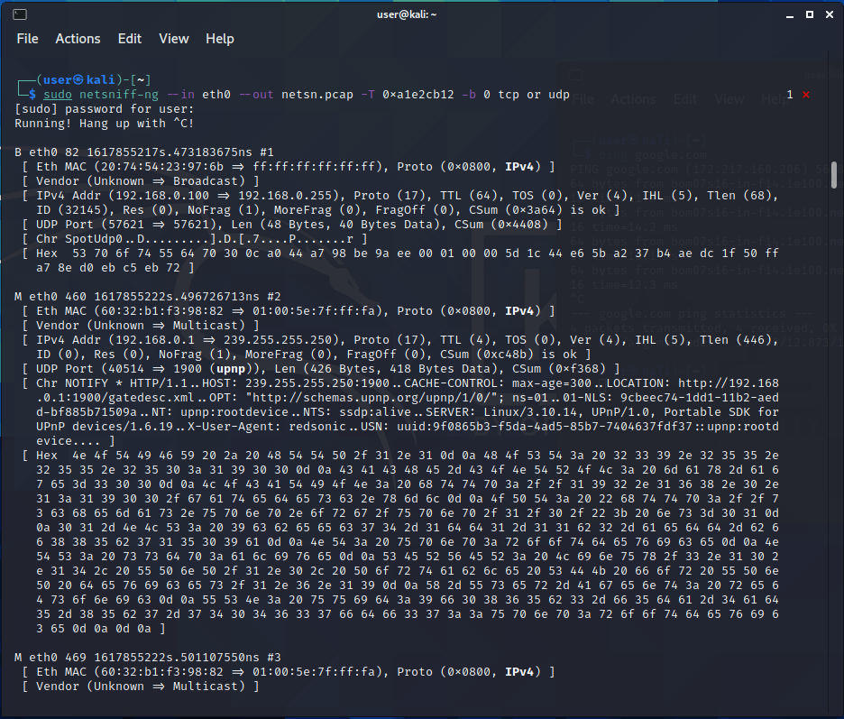

We can ping any website to check the packets travelling through given interface.

We can use -s for silent mode.

**CONCLUSION:**

In this practical, we learned sniffing tool called netsniff. We sniffed the interface of ethernet to check for packet transfer.

**PRACTICAL - 4**

**AIM**: Perform automated testing using BurpSuite or ZAP proxies.

**TOOL INTRODUCTION:**

1. **BurpSuite:**
   * Burp Suite is designed to be a hands-on tool, where the user controls the actions that are performed.
   * At the core of Burp's penetration testing workflow is the ability to pass HTTP requests between the Burp tools in order to carry out particular tasks.
   * You can send messages from the "Proxy" > "Intercept", "HTTP history", or "Site map" tabs, and indeed anywhere else in Burp that you see HTTP messages. To do this, select one or more messages, and use the context menu to send the request to another tool.
   * The Burp tools you will use for particular tasks are as follows:
     + Scanner - This is used to automatically scan websites for content and security vulnerabilities.
     + Intruder - This allows you to perform customized automated attacks, to carry out all kinds of testing tasks.
     + Repeater - This is used to manually modify and reissue individual HTTP requests over and over.
     + Collaborator client - This is used to generate Burp Collaborator payloads and monitor for resulting out-of-band interactions.
     + Clickbandit - This is used to generate clickjacking exploits against vulnerable applications.
     + Sequencer - This is used to analyze the quality of randomness in an application's session tokens.
     + Decoder - This lets you transform bits of application data using common encoding and decoding schemes.
     + Comparer - This is used to perform a visual comparison of bits of application data to find interesting differences.
2. **ZAP:**

* OWASP ZAP (short for Zed Attack Proxy) is an open-source web application security scanner. It is intended to be used by both those new to application security as well as professional penetration testers.
* It is one of the most active Open Web Application Security Project (OWASP) projects and has been given Flagship status.
* When used as a proxy server it allows the user to manipulate all of the traffic that passes through it, including traffic using https.
* It can also run in a daemon mode which is then controlled via a REST API.
* ZAP was added to the ThoughtWorks Technology Radar in May 2015 in the Trial ring.
* ZAP was originally forked from Paros, another pentesting proxy. Simon Bennetts, the project lead, stated in 2014 that only 20% of ZAP's source code was still from Paros.

**BurpSuite:**

Burpsuite is in built tool in Kali linux so we can directly open it by searching.

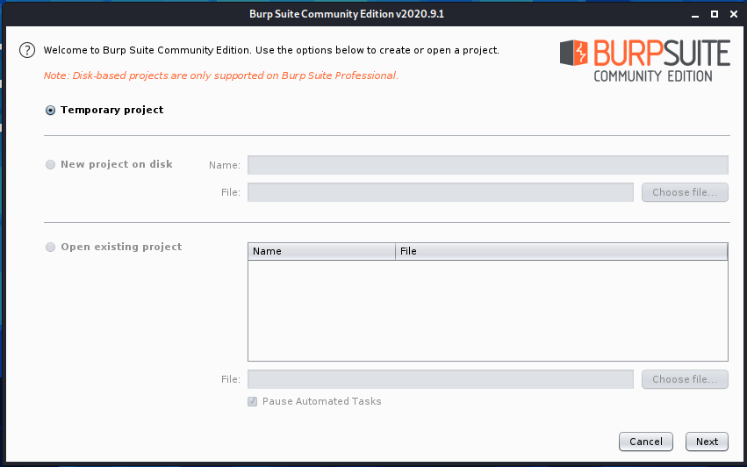

For now, we will create a temporary project and press next.

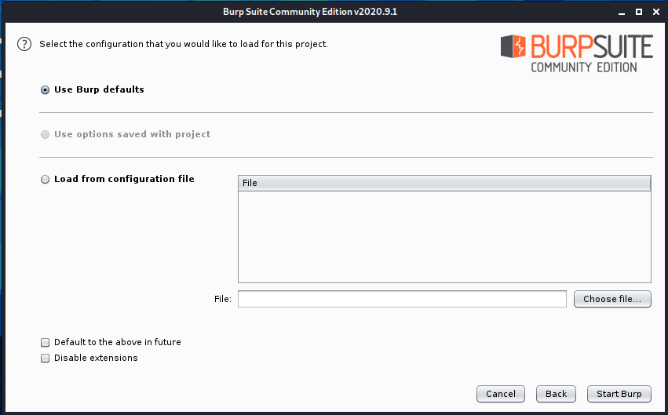

We will use default settings for now so we can start Burp.

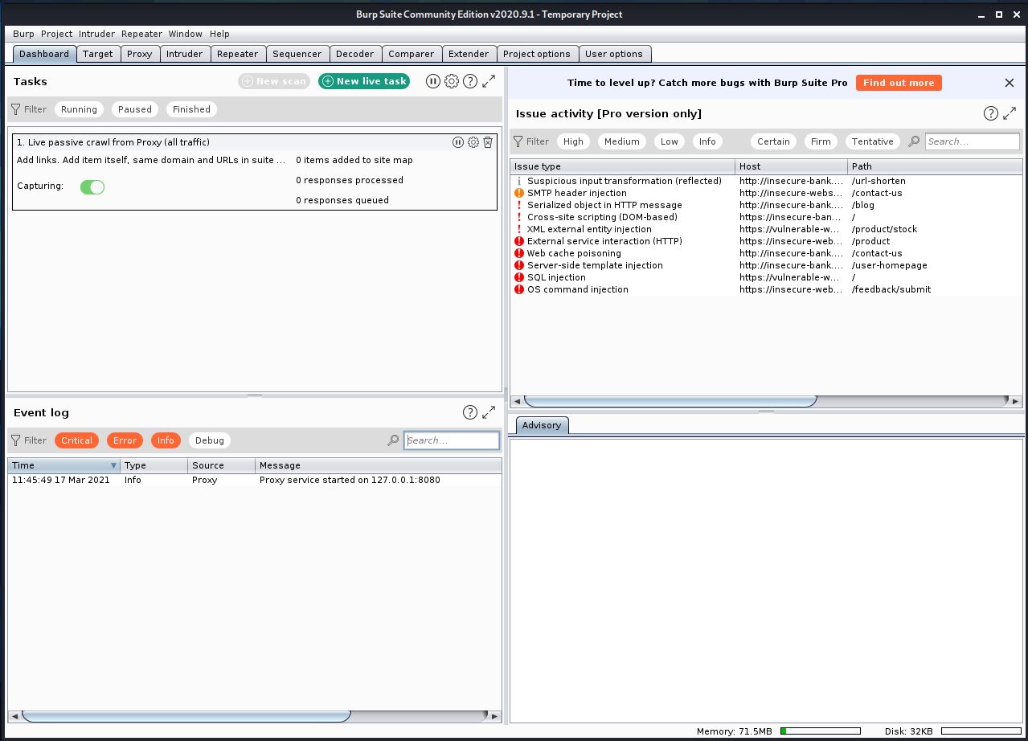

We will be able to see the dashboard like this when we enter Burp. We can perform many tasks in burp easily. Some of them are explained below.

**Using Proxy:**

* A proxy server acts as a gateway between you and the internet.
* We can use manual proxy from BurpSuite for browser too.
* We need to change the setting of proxy in browser too.
* Then when ‘intercept is on’, all the HTTP requests will only be forwarded if user permits them from BurpSuite.
* If we try to open any HTTP website using our browser, it will show the request like below in BurpSuite.

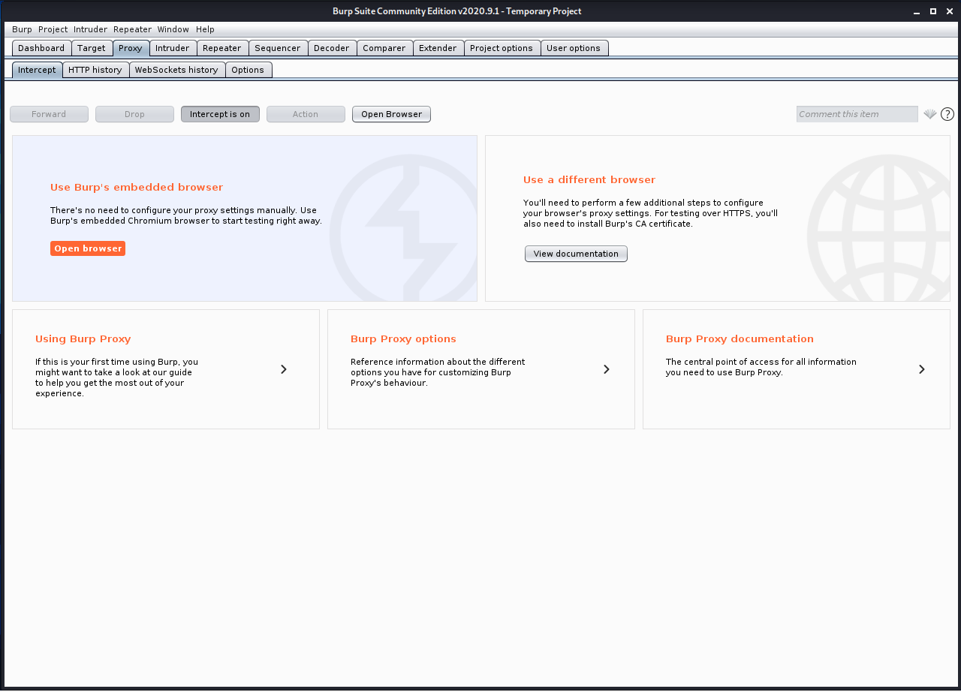

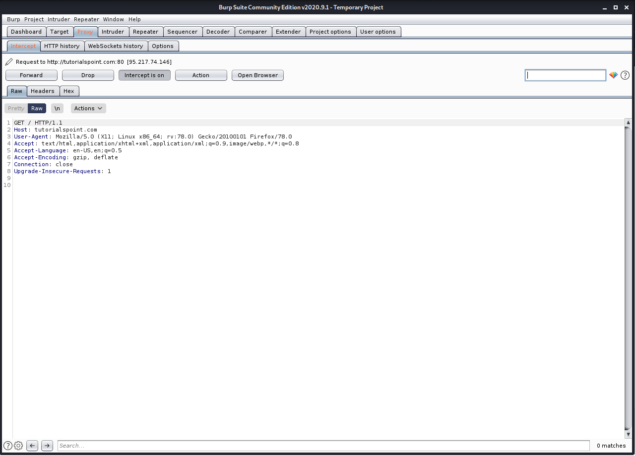

* We can forward them if we want or drop them.

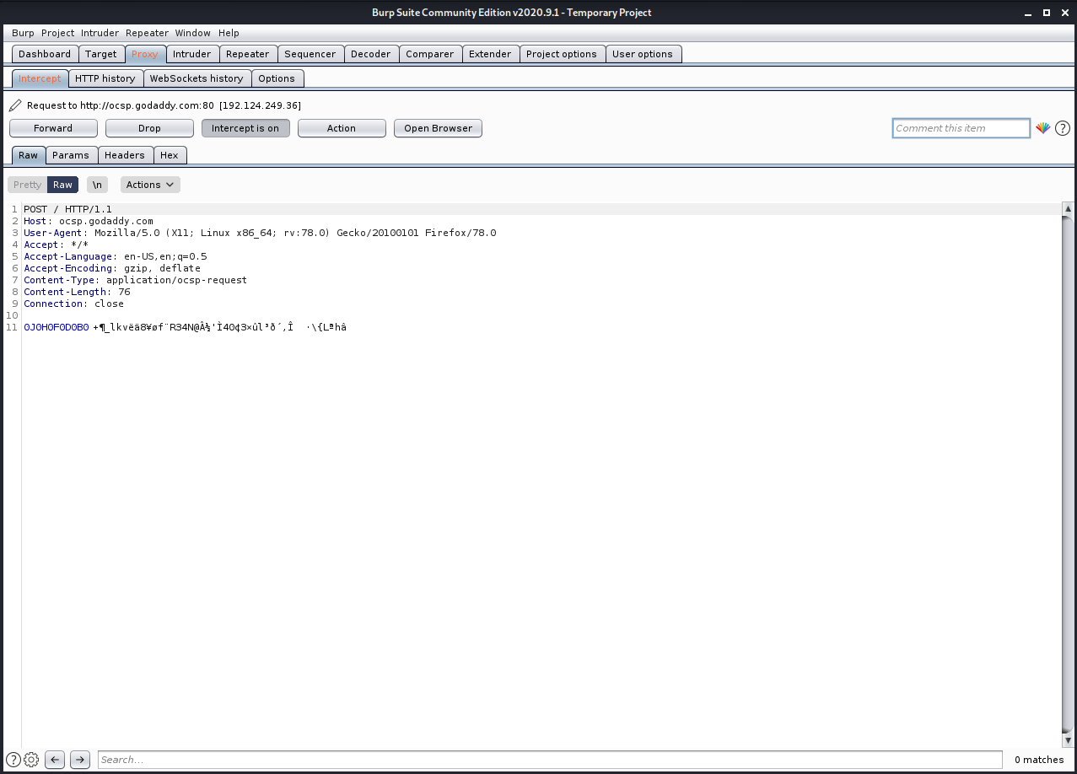

* We can look at the header of it by Header tab.

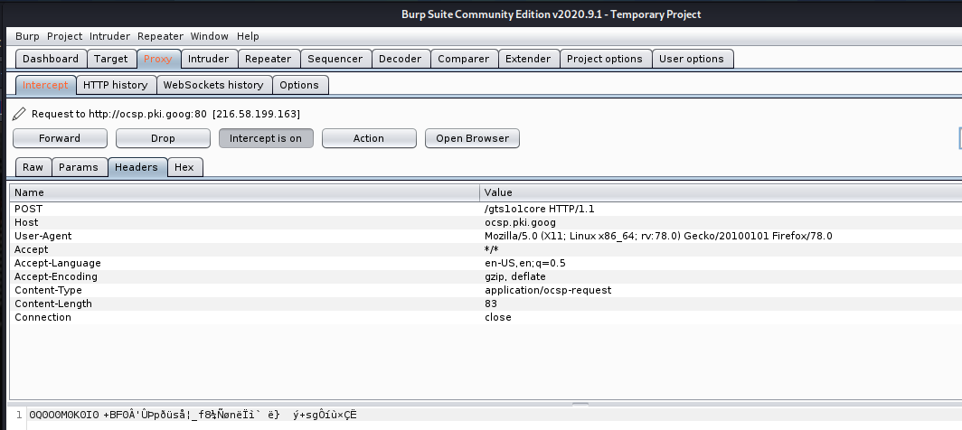

* We can see its Hex string in Hex tab.

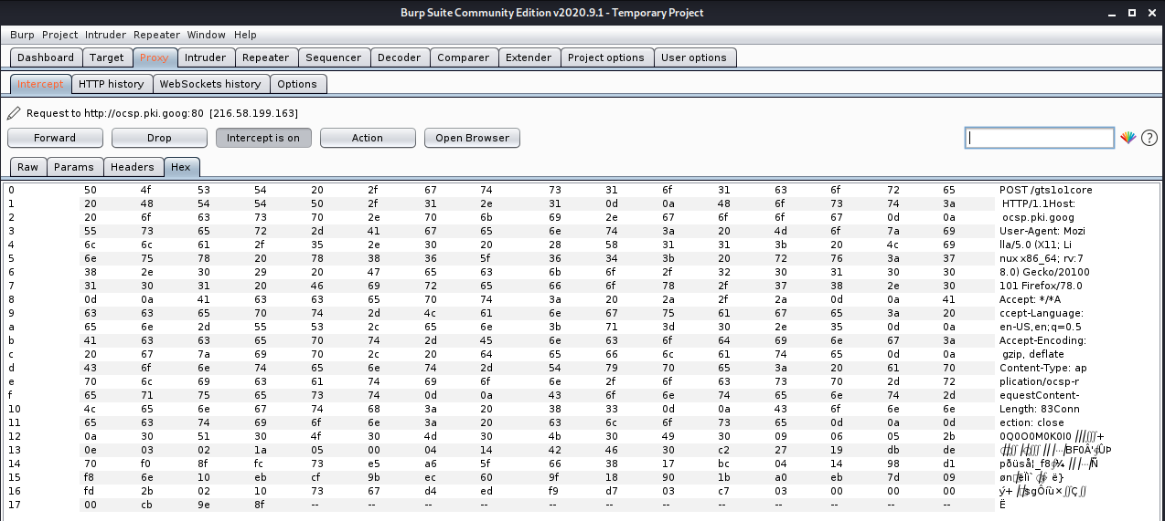

**Using Target:**

* The Target tool gives you an overview of your target application's content and functionality, and lets you drive key parts of your testing workflow.
* When we forwarded the packet, the website will be added to target

automatically.

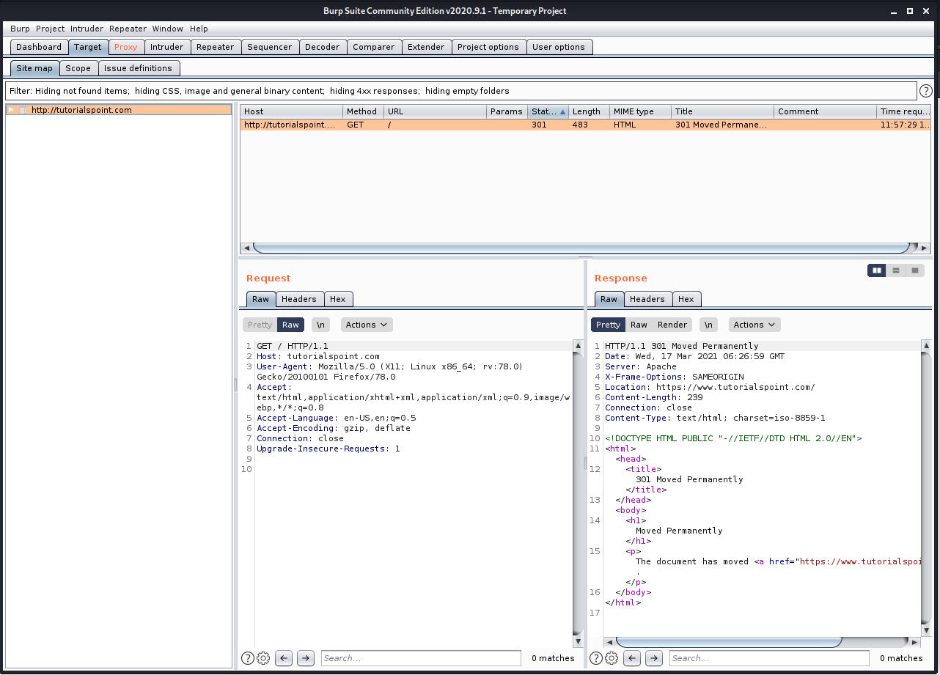

* Review the site map for any items in your target that have been detected via live

passive crawling but have not yet been requested. These items are shown in gray in the site map.

* We can add the URLs to scope for better traffic management.

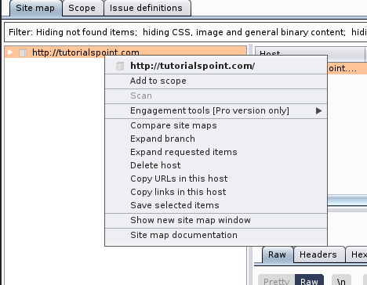

* It will ask to stop sending out-of-scope items to history, you can choose any option according to your need.

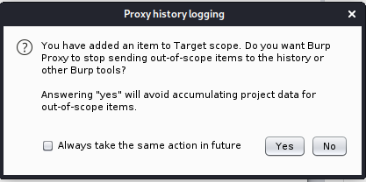

* The listed URI will be seen in Scope tab.

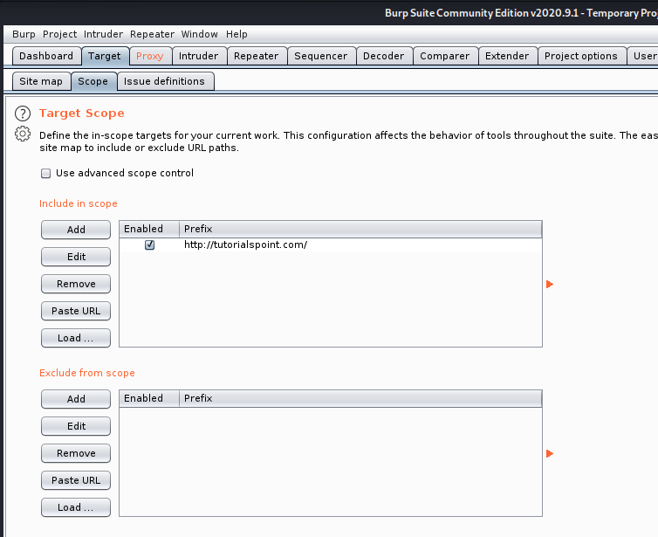

* We can set certain preferences based on whether the URL is listed in scope or out of scope like given below.

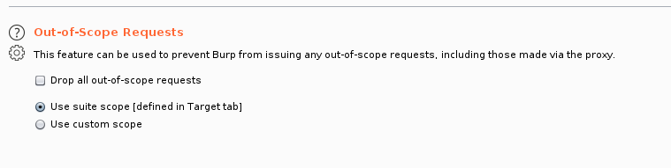

**Using Intruder:**

* Burp Intruder is a tool for automating customized attacks against web applications. It is extremely powerful and configurable, and can be used to perform a huge range of tasks, from simple brute-force guessing of web directories through to active exploitation of complex blind SQL injection vulnerabilities.
* We can send packets to intruder by right clicking on them and selecting ‘Send to Intruder’.

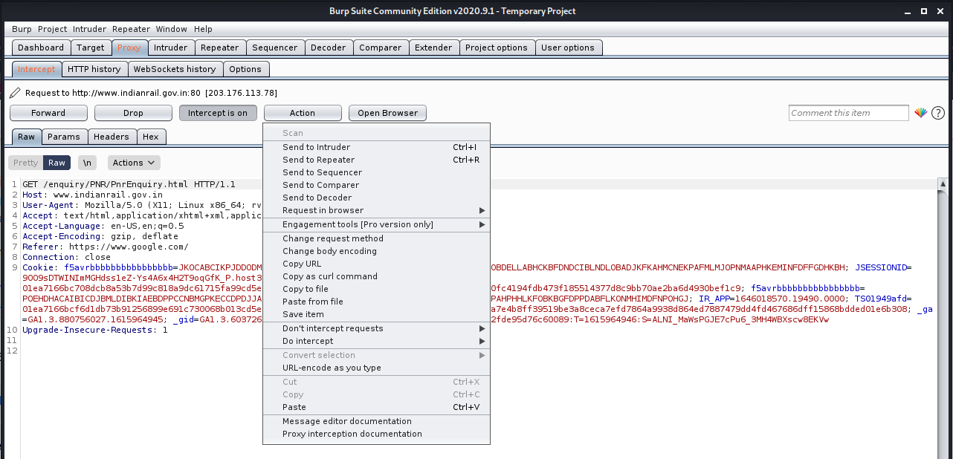

* According to the request you sent to intruder, it will automatically decide its host and port.

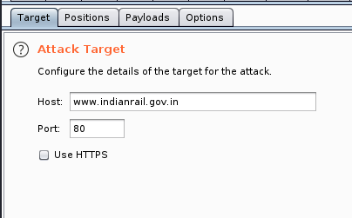

* In positions, you will see different customizable fields highlighted which we can attack on.

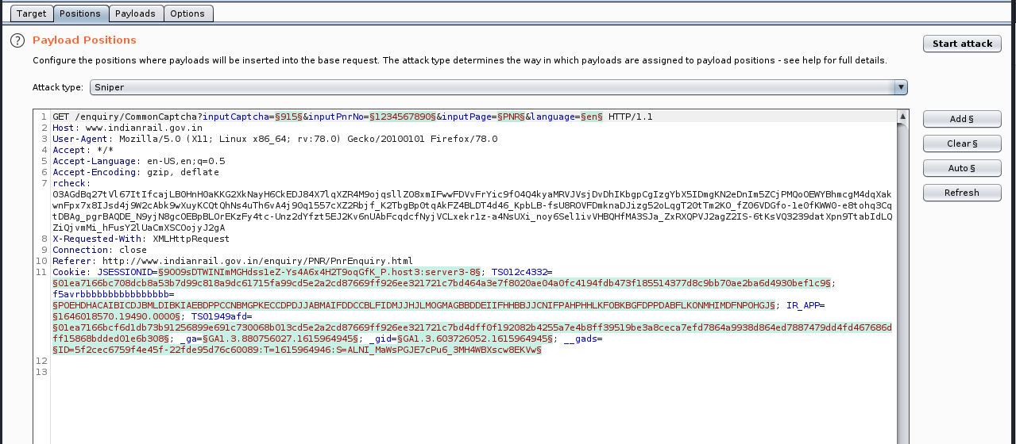

* For now, we want to try different PRN numbers so we will Clear all highlighted fields and only add the field we want to explore.
* We will keep attack as Sniper attack only.

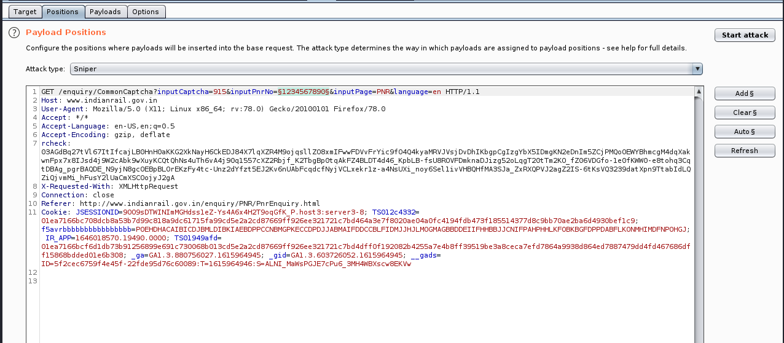

* Then in payloads tab, we will add the values we want to try.

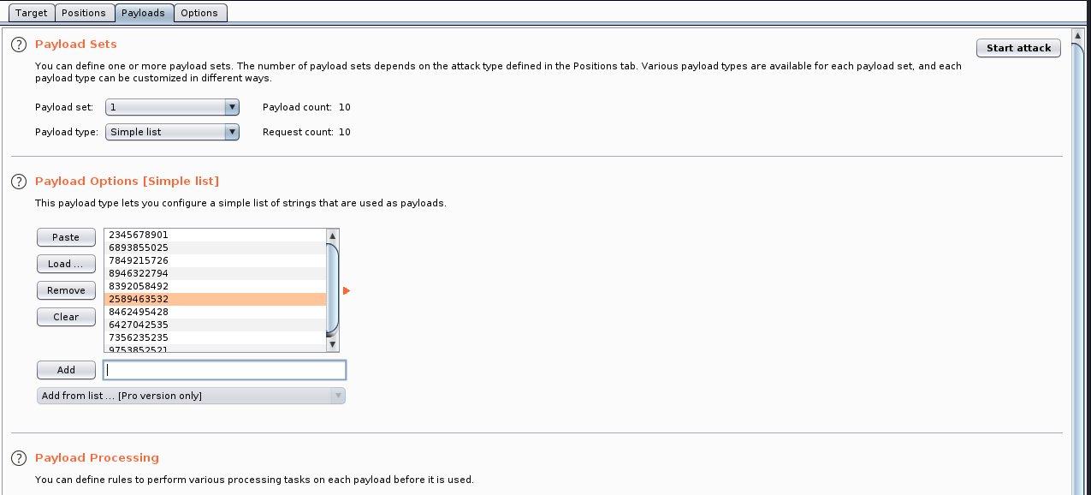

* We can start attack and we will be able to see the result in new window with server response with every values.

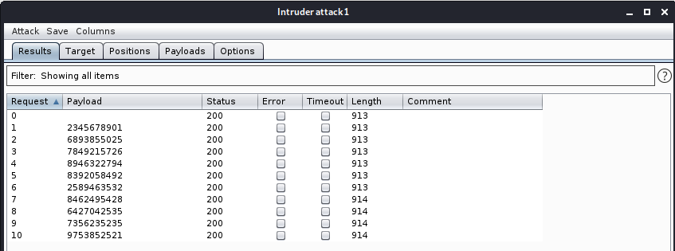

**Using Repeater:**

* Burp Repeater is a simple tool for manually manipulating and reissuing individual HTTP and WebSocket messages, and analyzing the application's responses.
* You can use Repeater for all kinds of purposes, such as changing parameter values to test for input-based vulnerabilities, issuing requests in a specific sequence to test for logic flaws, and reissuing requests from Burp Scanner issues to manually verify reported issues.
* The main Repeater UI lets you work on multiple different messages simultaneously, each in its own tab. When you send messages to Repeater, each one is opened in its own numbered tab. You can rename tabs by double-clicking the tab header.
* We can also send packet to Repeater tab from HTTP history tab of Proxy.

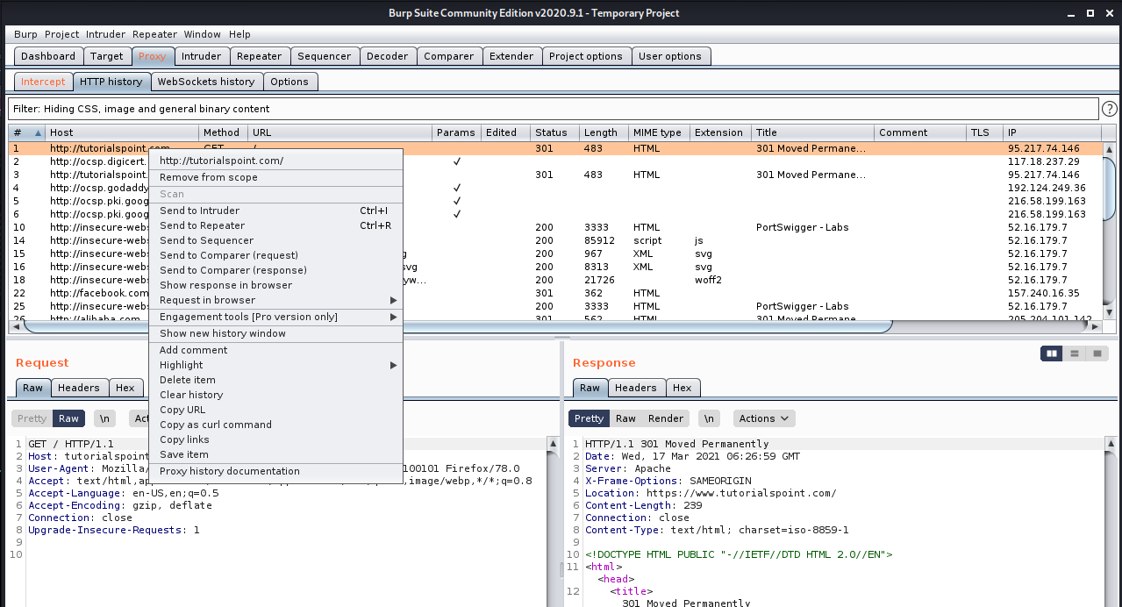

* Repeater will send the packet again to the server and show the received response.

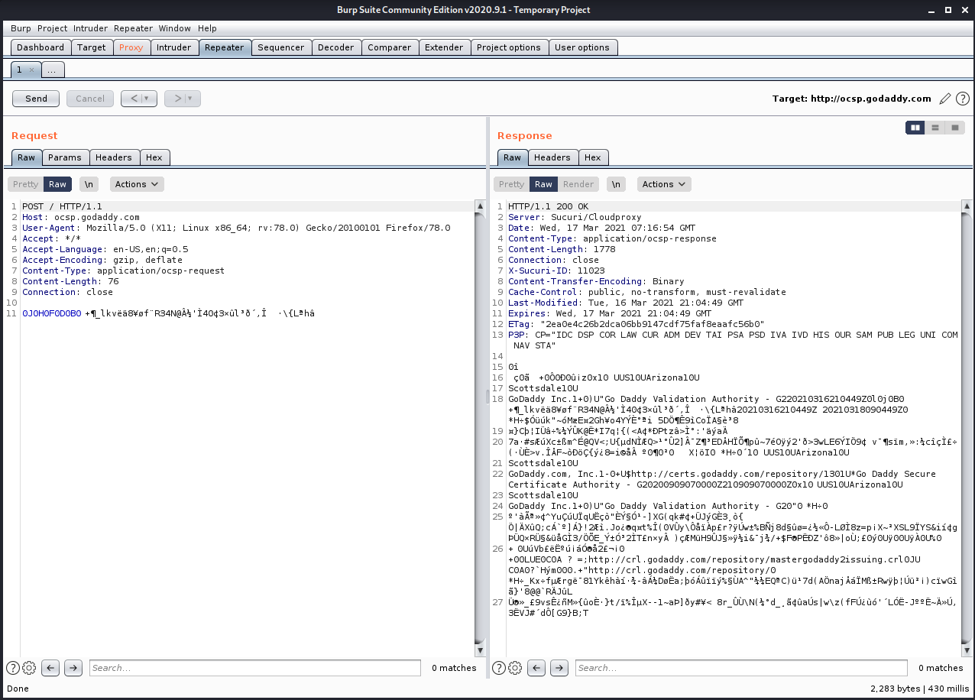

**Using Decoder:**

* Burp Decoder is a simple tool for transforming encoded data into its canonical form, or for transforming raw data into various encoded and hashed forms. It is capable of intelligently recognizing several encoding formats using heuristic techniques.
* We can send any packet to decoded and apply different encoding schemes and Hash functions

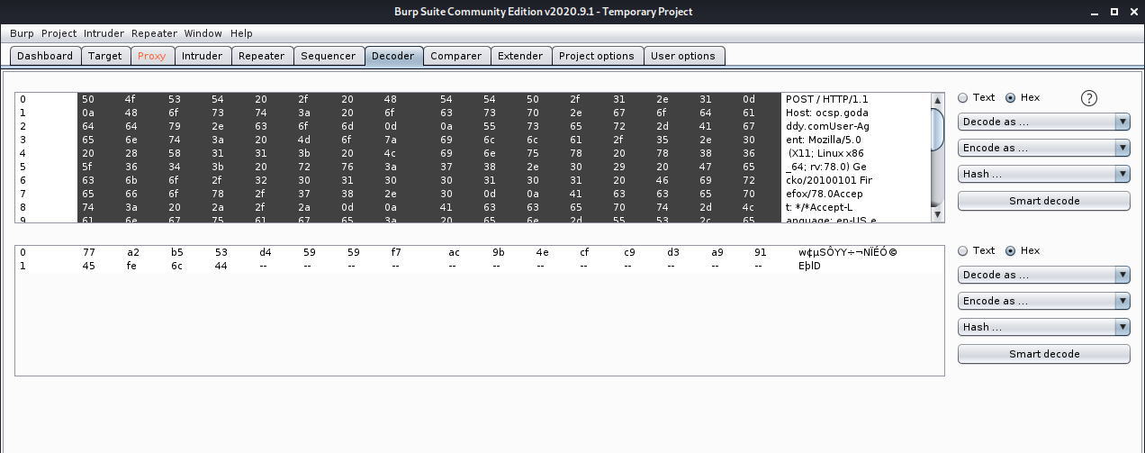

**Using Comparer:**

* Burp Comparer is a simple tool for performing a comparison (a visual "diff") between any two items of data.
* We can add two packets in comparer and compare them by Words or Bytes. We can see the result of comparison in new window.

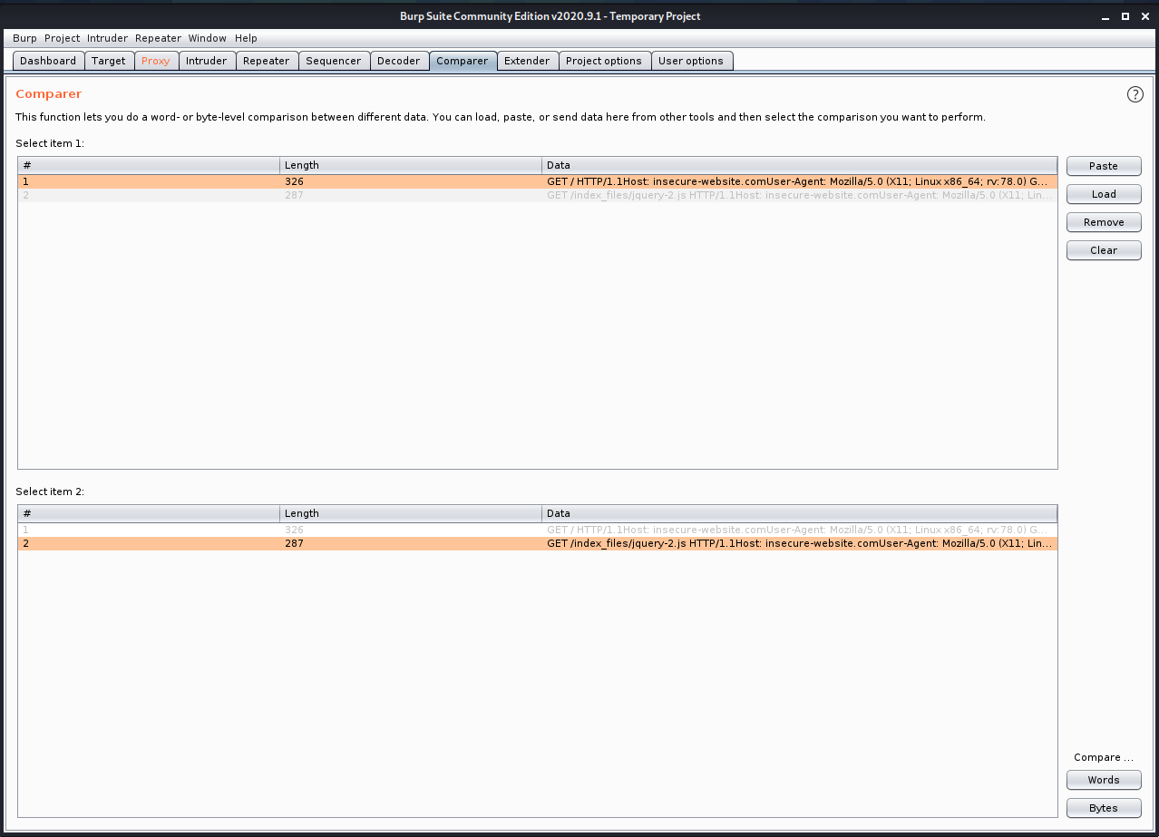

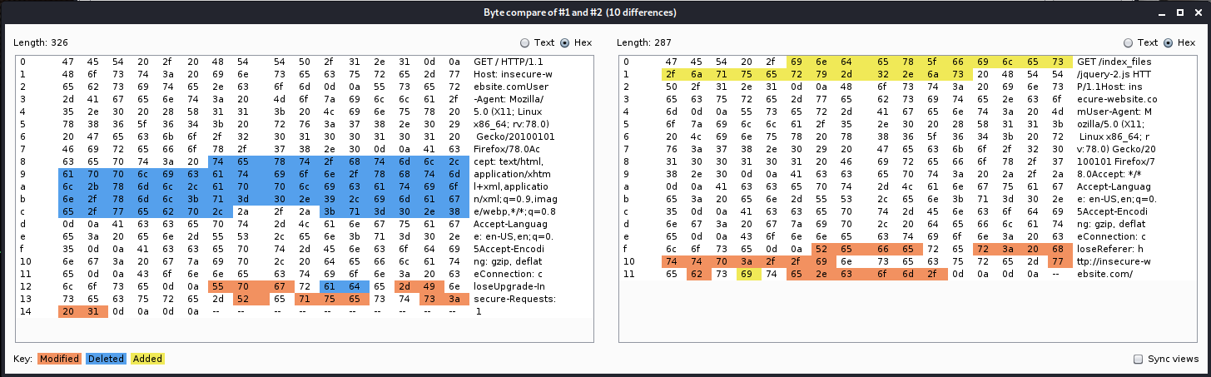

**CONCLUSION:**

In this practical, we learned about BurpSuite tool and used its different services to perform different tasks from easy tasks like decoding and comparing to high level tasks like repeating and setting proxy.

**PRACTICAL - 5**

**AIM**: Access remote terminal using SSH without password.

**TOOL INTRODUCTION:**

1. **SSH –** 
   * SSH or Secure Shell is a cryptographic network protocol for operating network services securely over an unsecured network.
   * Typical applications include remote command-line, login, and remote command execution, but any network service can be secured with SSH.
   * SSH provides a secure channel over an unsecured network by using a client–server architecture, connecting an SSH client application with an SSH server.
   * The protocol specification distinguishes between two major versions, referred to as SSH-1 and SSH-2. The standard TCP port for SSH is 22.
   * SSH is generally used to access Unix-like operating systems, but it can also be used on Microsoft Windows. Windows 10 uses OpenSSH as its default SSH client and SSH server.
   * SSH was designed as a replacement for Telnet and for unsecured remote shell protocols such as the Berkeley rsh and the related rlogin and rexec protocols.
   * Those protocols send information, notably passwords, in plaintext, rendering them susceptible to interception and disclosure using packet analysis.
   * The encryption used by SSH is intended to provide confidentiality and integrity of data over an unsecured network, such as the Internet.

We will have 2 Kali virtual machines and use client Kali to remotely access another Kali.

**On Server side:**

* We will make changes in /etc/ssh/sshd_config file.
* We will add “PermitRootLogin yes” and save it.

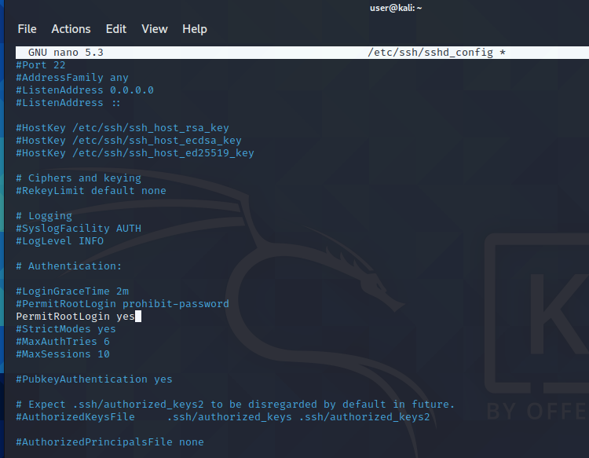

* Then we will check if SSH service is running or not.
* Command: service ssh status

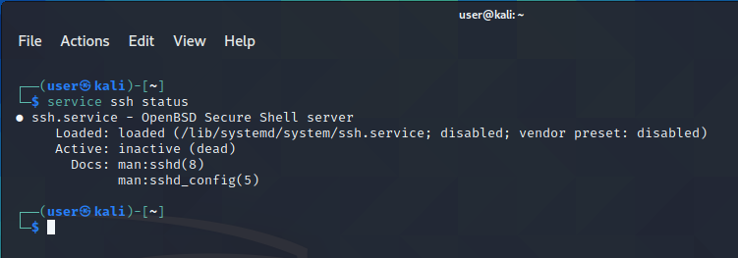

* If it is inactive (dead), we will run the following commands to enable and start it.
* Command sudo system enable ssh

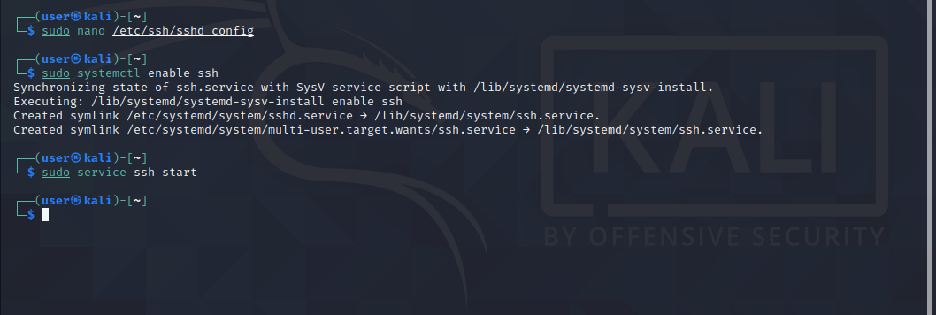

* Then we again we can check by same command and it should show status as active.

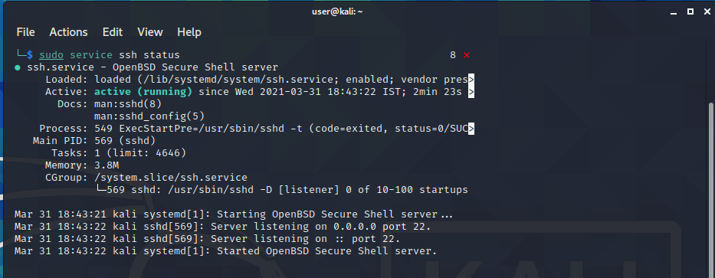

* We will check its IP address to connect.
* Command : ip address

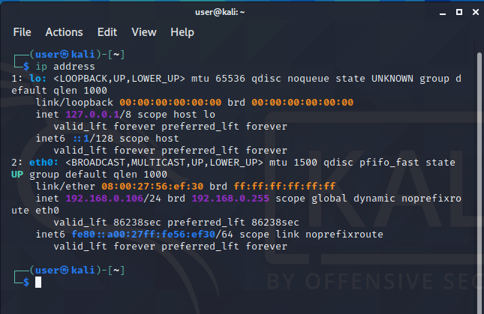

**On Client Side:**

* We will again enable SSH service on client side first.
* Then we need to create rsa public key.
* To generate key, we will use following commands.
* Command : ssh-keygen -t rsa

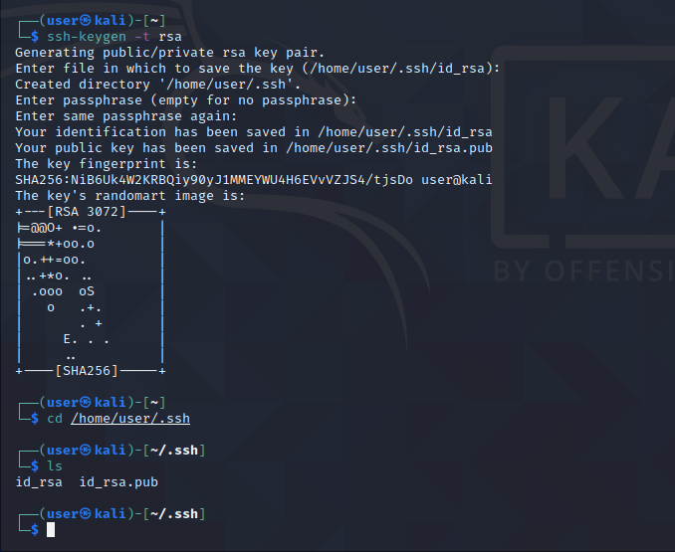

* We will share the public ckey with the server with which we want to connect.
* Command: ssh-copy-id -I id_rsa.pub 192.168.0.106
* Notice that filename (id_pub.pub) and IP address of server (192.168.0.106) may change according to user.

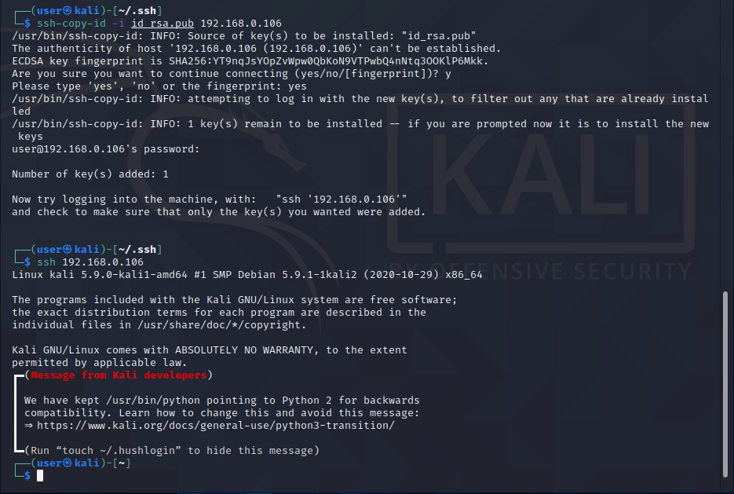

* Now we can connect to server using SSH.
* Command: ssh 192.168.0.106
* IP address may change according to situation.



* We’re connected to server machine now.
* We can check by creating new folder or file in server machine which will reflect in client’s terminal.
* We can also check IP address command to check IP of connected machine.
* Here I have created a folder on desktop of server machine which gets reflected.

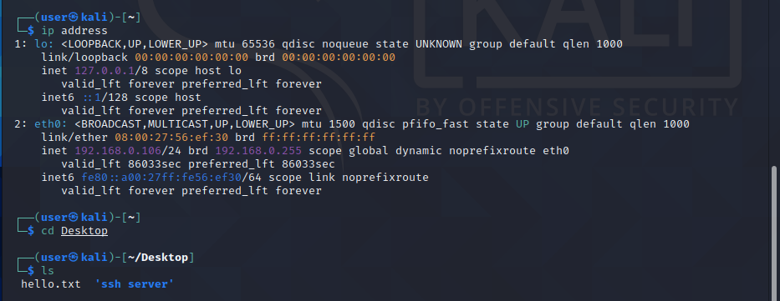

**CONCLUSION:**

In this practical, we learned about SSH and remotely accessed a machine using another. We learned how SSH can be very useful in applications like Putty, SecureCRT, MremoteNG, MotaXterm etc.

**PRACTICAL - 6**

**AIM**:

In computers, Footprinting is the process of accumulating data regarding a specific network environment, usually for the purpose of finding ways to intrude into the environment. Footprinting can reveal system vulnerabilities and improve the ease with which they can be exploited. Use the given approach to implement Footprinting: Gathering Target Information making use of following tools:

* Dmitry – Deepmagic
* UA Tester
* Whatweb

**TOOL INTRODUCTION:**

1. **Dmitry - Deepmagic:**

* DMitry (Deepmagic Information Gathering Tool) is a UNIX/(GNU)Linux Command Line Application coded in C. DMitry has the ability to gather as much information as possible about a host.
* Base functionality is able to gather possible subdomains, email addresses, uptime information, tcp port scan, whois lookups, and more.
* The following is a list of the current features:
* An Open Source Project.
* Perform an Internet Number whois lookup.
* Retrieve possible uptime data, system and server data.
* Perform a SubDomain search on a target host.
* Perform an E-Mail address search on a target host.
* Perform a TCP Portscan on the host target.
* A Modular program allowing user specified modules

1. **UA-Tester:**

* This tool is designed to automatically check a given URL using a list of standard and non-standard User Agent strings provided by the user (1 per line).
* The results of these checks are then reported to the user for further manual analysis where required. Gathered data includes Response Codes, resulting URL in the case of a 30x response,
* MD5 and length of response body, and select Server headers.
* Results: When in non-verbose mode, only values that do not match the initial reference connection are reported to the user.
* If no results are shown for a specific user agent then all results match the initial reference connection.
* If you require a full output of all checks regardless of matches to the reference, please use the verbose setting.

1. **Whatweb:**
   * WhatWeb identifies websites.
   * Its goal is to answer the question, “What is that Website?”.
   * WhatWeb recognizes web technologies including content management systems (CMS), blogging platforms, statistic/analytics packages, JavaScript libraries, web servers, and embedded devices. WhatWeb has over 1700 plugins, each to recognise something different.
   * WhatWeb also identifies version numbers, email addresses, account IDs, web framework modules, SQL errors, and more.
   * WhatWeb can be stealthy and fast, or thorough but slow.
   * WhatWeb supports an aggression level to control the trade off between speed and reliability.
   * When you visit a website in your browser, the transaction includes many hints of what web technologies are powering that website.
   * Sometimes a single webpage visit contains enough information to identify a website but when it does not, WhatWeb can interrogate the website further.
   * The default level of aggression, called ‘stealthy’, is the fastest and requires only one HTTP request of a website.
   * This is suitable for scanning public websites. More aggressive modes were developed for use in penetration tests.

**Dmitry - Deepmagic:**

We can find Dmitry in Information Gathering section.

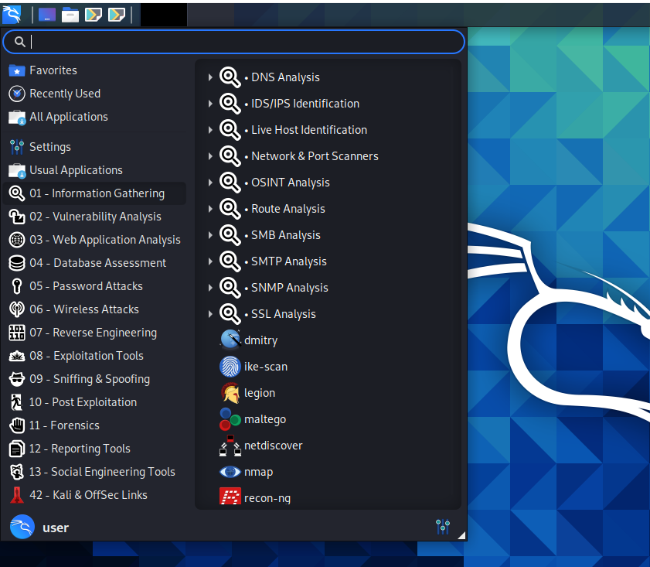

Command: Dmitry -winsepo hackthissite.org

We can use any website as target.

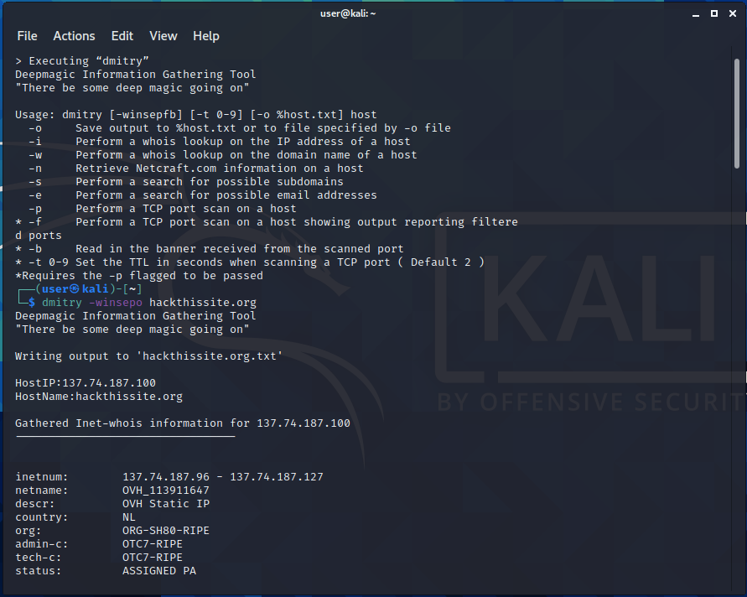

The output is stored in “hackthissite.org.txt” file.

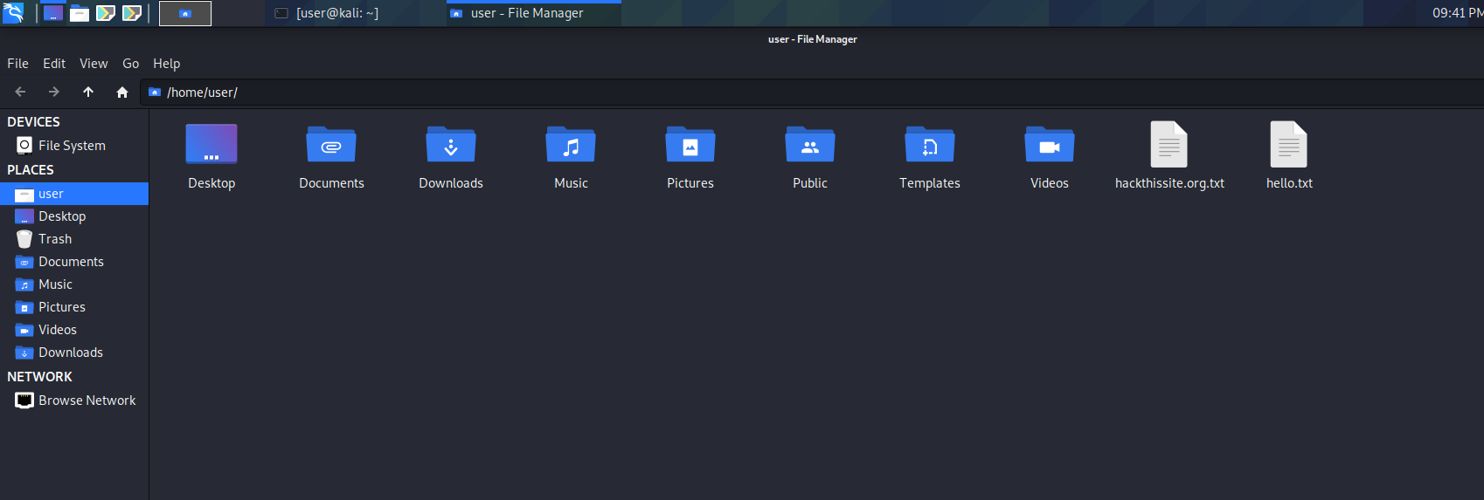

**UA Tester:**

We can use UA tester directly from terminal.

Command: ua-tester -u [www.charusat.ac.in](http://www.charusat.ac.in) -d M D

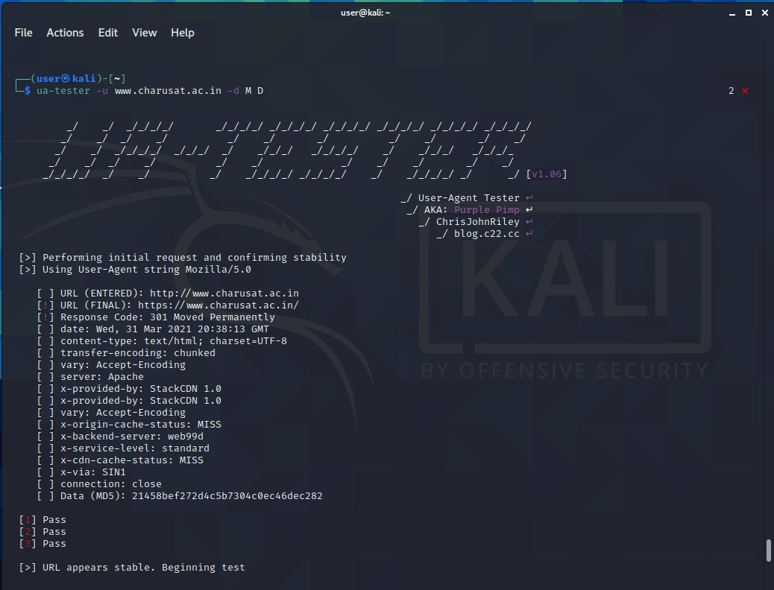

**Whatweb:**

We can also use Whatweb directly from terminal.

Command: whatweb -v <https://sites.google.com/charusat.ac.in/pnp>

We can use any website we want as target.

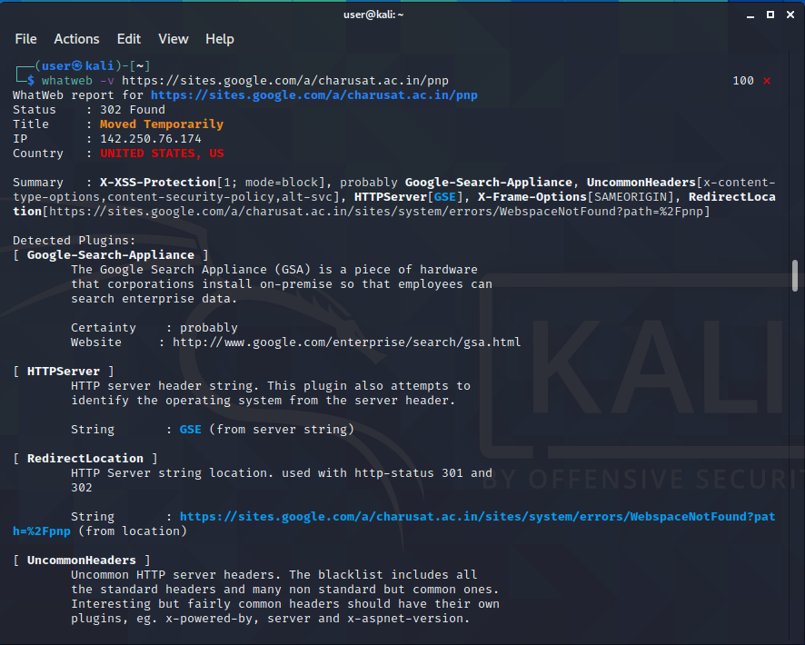

**CONCLUSION:**

In this practical, we learned tools like Dmitry, UA-tester and Whatweb for information gathering.

**PRACTICAL - 7**

**AIM**: The transmission of information needs to be secure over the communication channel and the data has to be confidential. Study and implement the practical approach for Steganography.

* -Using DOS commands
* -Using OpenPuff Tool

**TOOL INTRODUCTION:**

1. OpenPuff –

* OpenPuff Steganography and Watermarking, sometimes abbreviated OpenPuff or Puff, is a free steganography tool for Microsoft Windows created by Cosimo Oliboni and still maintained as independent software. The program is notable for being the first steganography tool (version 1.01 released on December 2004) that:
  + 1. lets users hide data in more than a single carrier file. When hidden data are split among a set of carrier files you get a carrier chain, with no enforced hidden data theoretical size limit (256MB, 512MB, ... depending only on the implementation)
    2. implements 3 layers of hidden data obfuscation (cryptography, whitening and encoding)
    3. extends deniable cryptography into deniable steganography
* Last revision supports a wide range of carrier formats
  + 1. Images Bmp, Jpg, Png, Tga
    2. Audios Aiff, Mp3, Wav
    3. Videos 3gp, Mp4, Mpeg I, Mpeg II, Vob
    4. Flash-Adobe Flv, Pdf, Swf
* OpenPuff is used primarily for anonymous asynchronous data sharing:

1. the sender hides a hidden stream inside some public available carrier files (password + carrier files + carrier order are the secret key)
2. the receiver unhides the hidden stream knowing the secret key

* The advantage of steganography, over cryptography alone, is that messages do not attract attention to themselves. Plainly visible encrypted messages — no matter how unbreakable — will arouse suspicion, and may in themselves be incriminating in countries where encryption is illegal. Therefore, whereas cryptography protects the contents of a message, steganography can be said to protect both messages and communicating parties.
* Watermarking is the action of signing a file with an ID or copyright mark. OpenPuff does it in an invisible steganographic way, applied to any supported carrier. The invisible mark, being not password protected, is accessible by everyone (using the program).

**Using DOS Command:**

* Easy way to use steganography is using DOS command.
* We can hide a text message into any image using following command.
* Command: echo secret message>image
* Ex: echo this is a secret>image.jpg
* We can get the secret message back using notepad.
* Command: notepad image
* Ex: notepad image.jpg

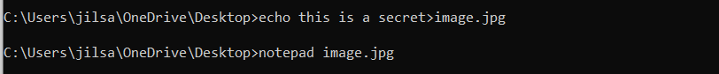

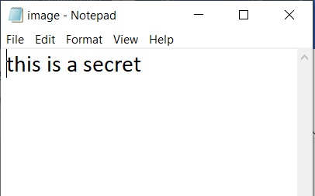

**Using OpenPuff:**

* OpenPuff provides more services that command prompt.
* Instead of using commands, we can directly use GUI in openpuff.

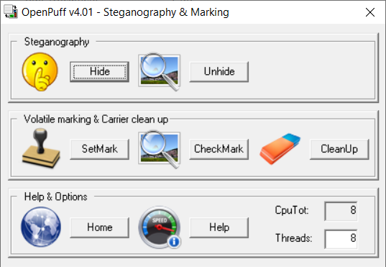

* We can select Hide option to hide our text file into image file.
* We can set password and give image and text files as input.
* On pressing “Hide Data!” we can select the location to save our output.

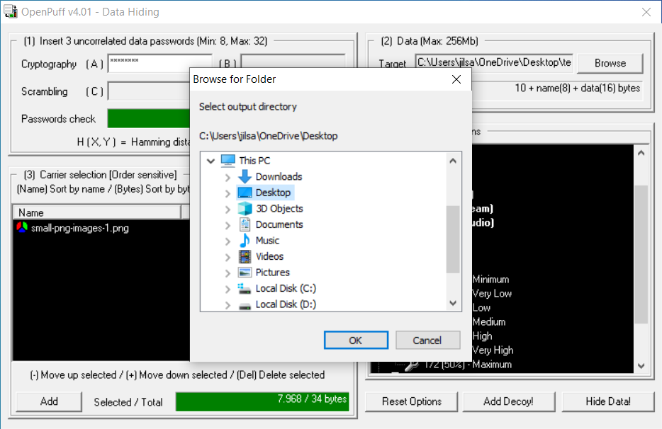

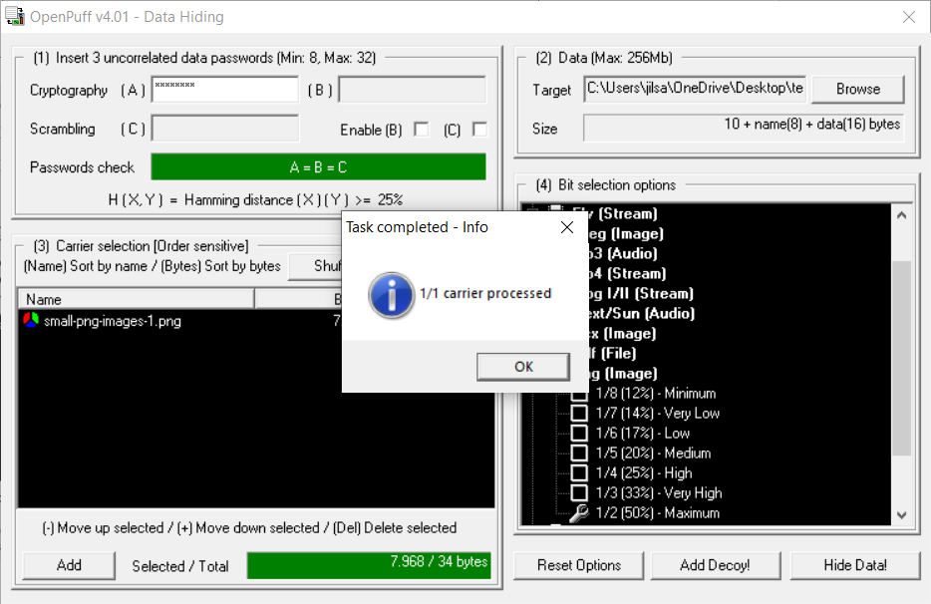

* We can recover the secret message by giving the image and password we used earlier.

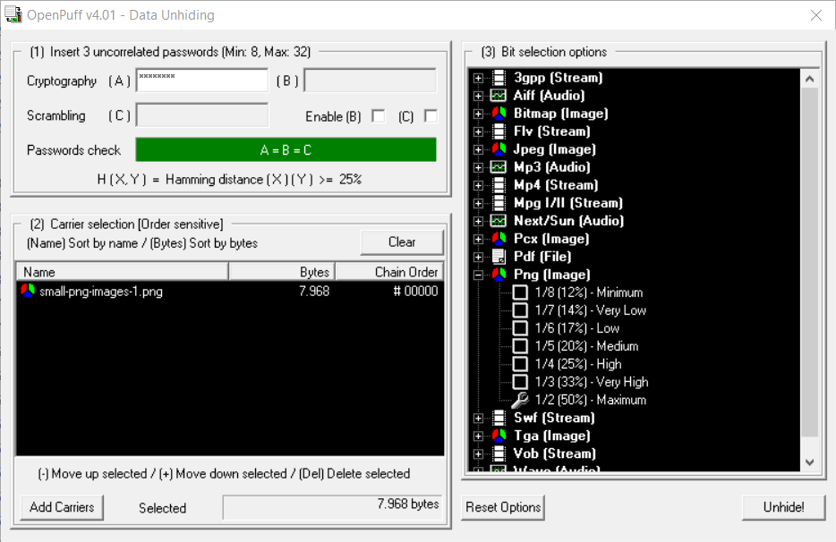

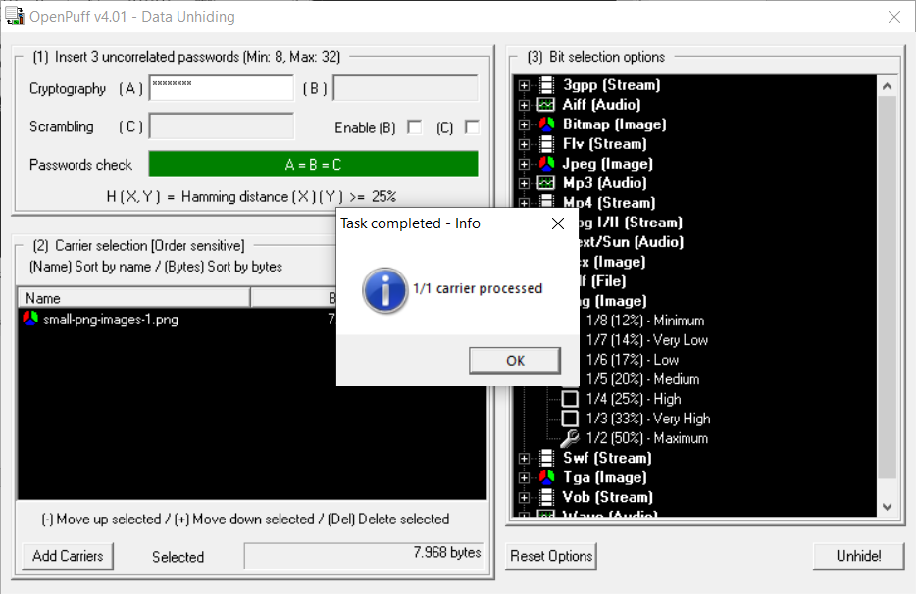

* OpenPuff can also be used for Watermarking.
* We can easily create watermarking using “SetMark” option.

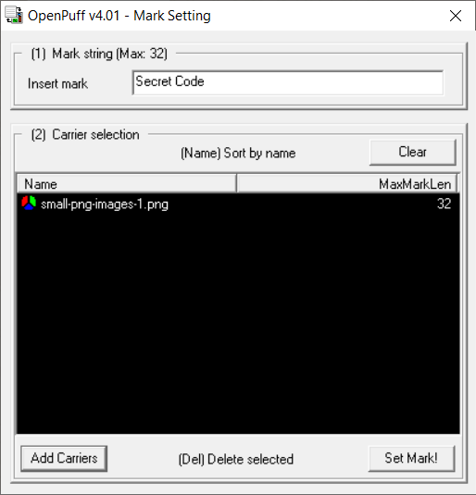

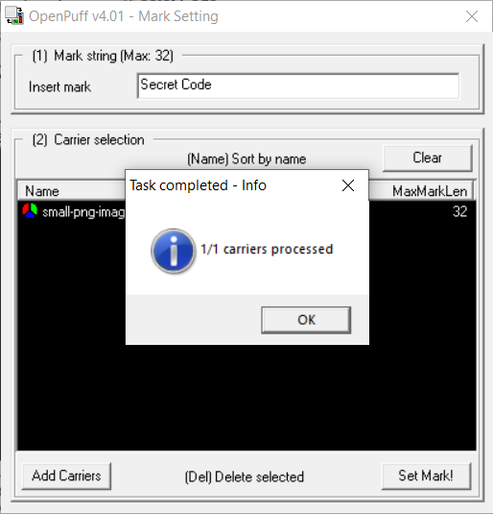

* We can check if any image contains watermark using “CheckMark” option.

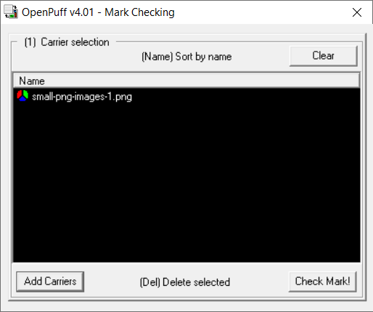

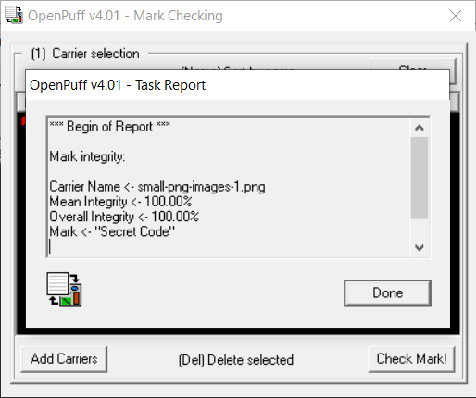

* We can permanently remove watermark using “CleanUp” option.

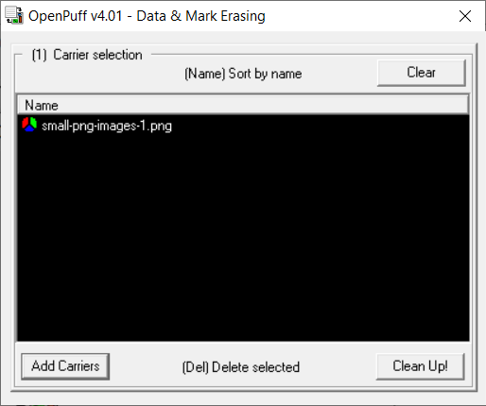

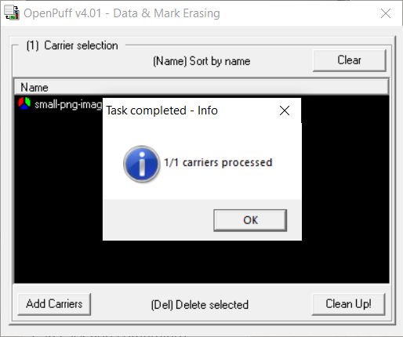

**Similar Tools as OpenPuff:**

* **ImageSpyer G2:**
  + The utility allows you to hide information in images using techniques of modern steganography, and the data will be encrypted by two-layer cryptographic protection, which including more than twenty block ciphers (for data protection) and powerful stream cipher to encrypt stego.
  + Mechanisms used in the program, aimed at not only to hide existence of the data, but also guaranteed to protect it from possible attacks.
  + Through the use of a powerful compression algorithm, the available capacity is significantly increased.
  + Besides powerful cryptographic security is provided by a number of privacy settings, without knowing that an attacker can not determine the presence of hidden information.
* **MP3Stego**:
  + MP3Stego is a typical steganographic tool for MP3 audio, which embeds secret message into MP3 audio according to the parity of the block length. In this paper, a detection method for MP3Stego based on the differential statistics of quantization step is present.
  + By analyzing the algorithm of MP3Stego, we find that the quantization step which is an important parameter of MP3 encoding is affected during embedding.
  + The standard deviation of the second-order differential sequence from quantization step is adopted as the classification feature.
  + Experimental results indicate that the proposed algorithm is effective in detecting MP3Stego and can achieve better detection performance than the existing algorithms.
* **S-Tools:**
  + S-Tools is an extremely simple tool that can be used to hide text files in images.
  + The tool is present in zip format, just extract it and create a simple text file which has the data you want to hide.
  + Save a cover photo in which the data will be hidden. Just run the .exe file and drag the BMP file to that window.
  + Then drag the text file over the image and select the encryption algorithm to embed the file.
  + The options available are IDEA, DES, triple DES etc. Select a passphrase that will be used to reveal the hidden files from the images.
  + Just use the same process to reveal the contents that have been hidden in the file.
* **StegoShare:**
  + StegoShare is a steganography tool that allows embedding of large files into multiple images.
  + It may be used for anonymous file sharing. This software can be easily used for anonymous file sharing.
  + An uploader downloads legal images from a public photo hosting site, and embeds the censored file into those images.
  + The uploader then uploads pictures to the public photo torrent tracker and puts the links referencing the stego pictures with censored file's description on a forum or blog. Downloaders, seeders, and public photo trackers, if caught distributing illegal files, are protected from legal prosecution, because they can always use plausible deniability, saying that they knew nothing about the illicit file in the images.
  + This is impossible to prove otherwise, as the human eye cannot differentiate between an ordinary image and a picture with hidden embedded file.
* **BMPSecrets:**
  + HexaStego–BMP is a very small steganography tool (only 10KB in size) for hiding a message in unrelated information.
  + It can hide relatively small files (around 50KB) within .bmp graphic file. The image is slightly altered throughout the process, and this change is only noticeable if the modified and original files are viewed simultaneously.
  + The hidden file can be extracted using the same utility.

**CONCLUSION:**

In this practical, we learned about steganography and watermarking. We implemented them in real image using command prompt and OpenPuff. We also got to know about different tools as OpenPuff.

**PRACTICAL - 8**

**AIM**: Using OWASP-ZAP tool to find out Web Application Vulnerability.

**TOOL INTRODUCTION:**

**OWASP-ZAP:**

* OWASP ZAP (short for Zed Attack Proxy) is an open-source web application security scanner. It is intended to be used by both those new to application security as well as professional penetration testers.
* It is one of the most active Open Web Application Security Project (OWASP) projects and has been given Flagship status.
* When used as a proxy server it allows the user to manipulate all of the traffic that passes through it, including traffic using https.
* It can also run in a daemon mode which is then controlled via a REST API.
* ZAP was added to the ThoughtWorks Technology Radar in May 2015 in the Trial ring.
* ZAP was originally forked from Paros, another pentesting proxy. Simon Bennetts, the project lead, stated in 2014 that only 20% of ZAP's source code was still from Paros.
* Some of the built in features include: Intercepting proxy server, Traditional and AJAX Web crawlers, Automated scanner, Passive scanner, Forced browsing, Fuzzer, WebSocket support, Scripting languages, and Plug-n-Hack support.
* It has a plugin-based architecture and an online ‘marketplace’ which allows new or updated features to be added. The GUI control panel is easy to use.

**ZAP:** We can find Zap in Web Application Analysis.

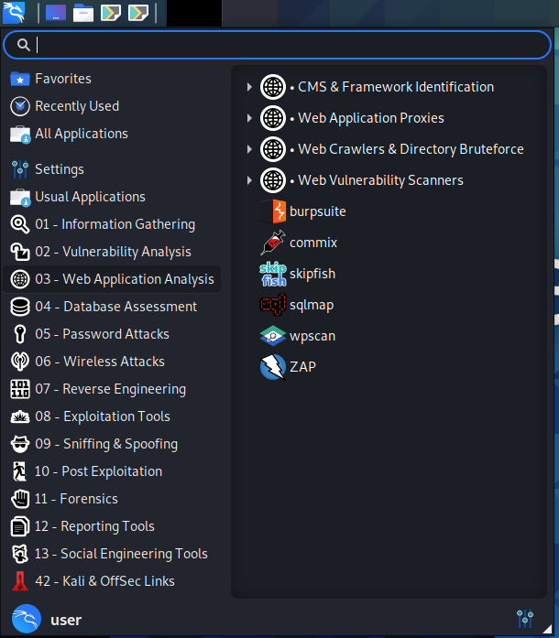

We will be able to see the main screen of ZAP.

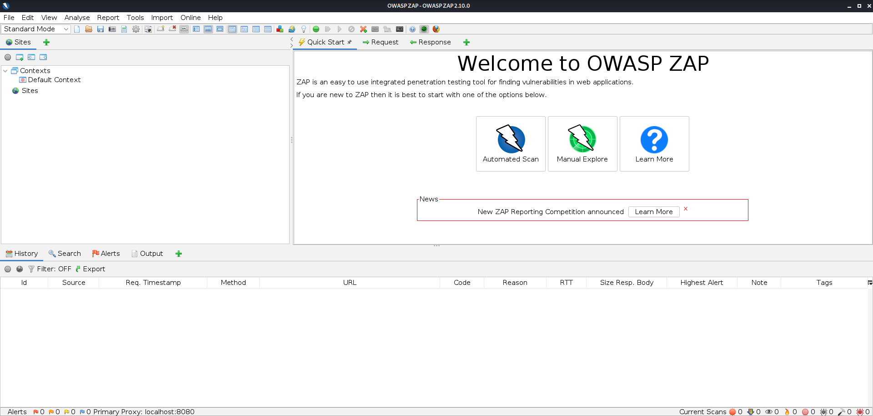

We will go to automated scan.

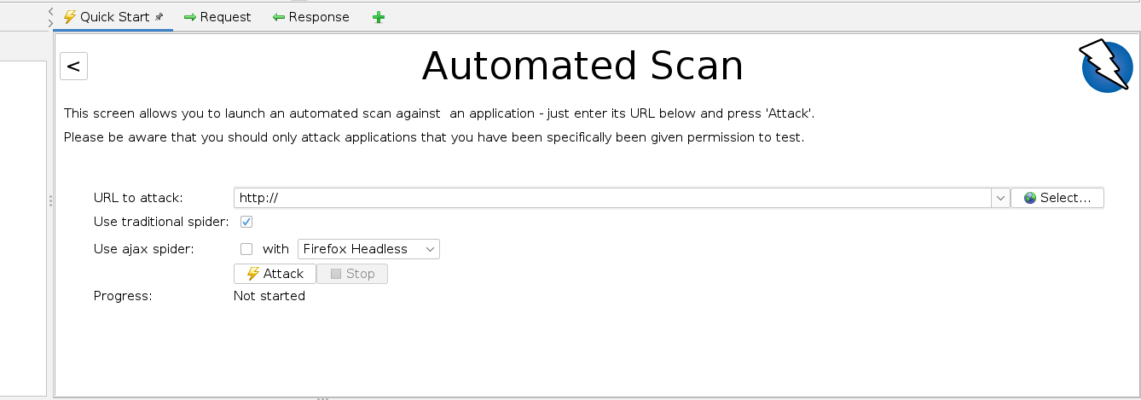

We can now enter the website we want to analyze and click “Attack”.

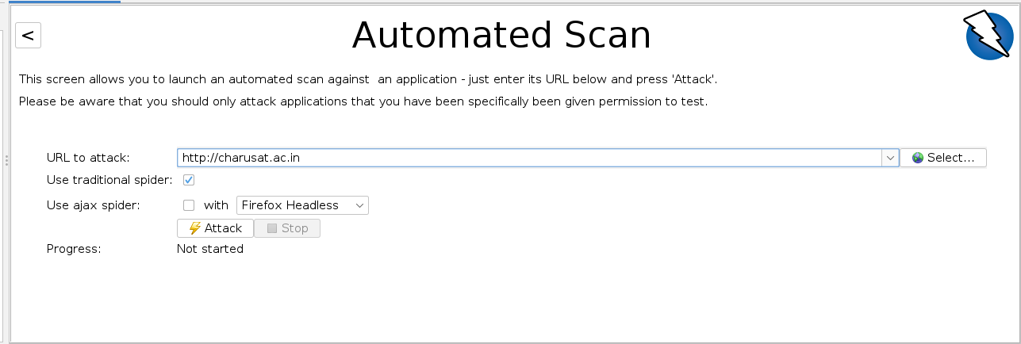

We will see all found pages in Spider tab below.

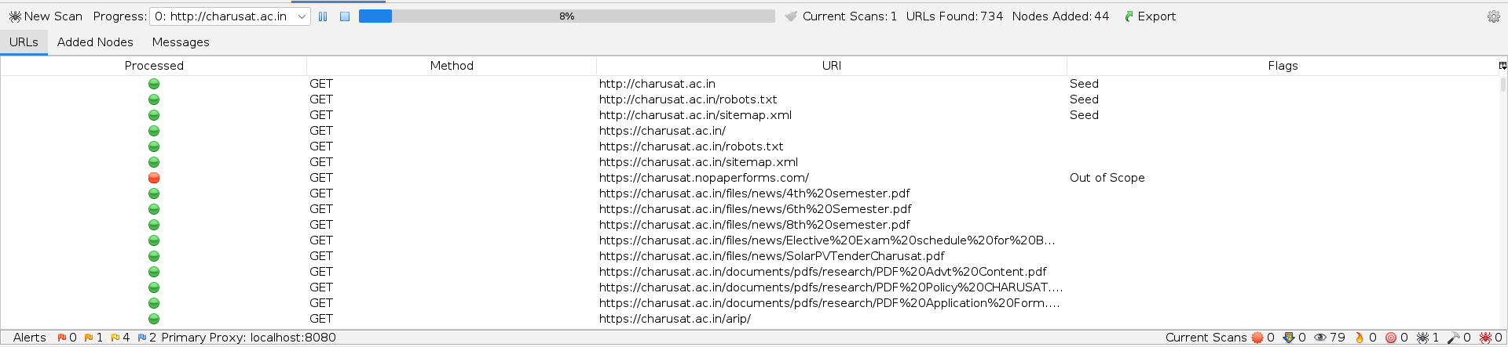

We can see more details in message tab.

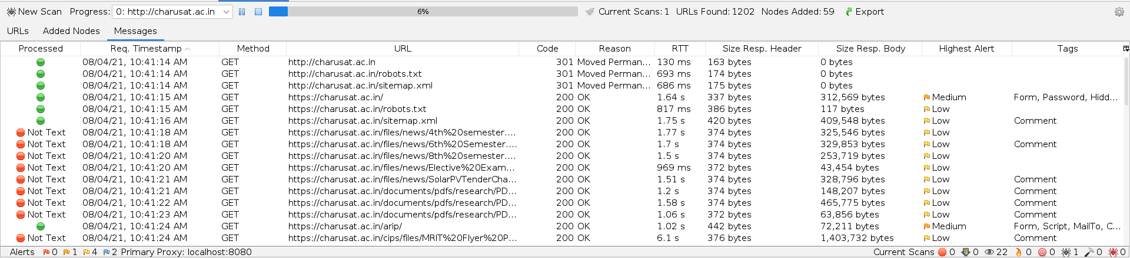

We can see alerts in alert tab with different color flags.

We can see the summary of it in bottom section too which will show the numbers of alerts.

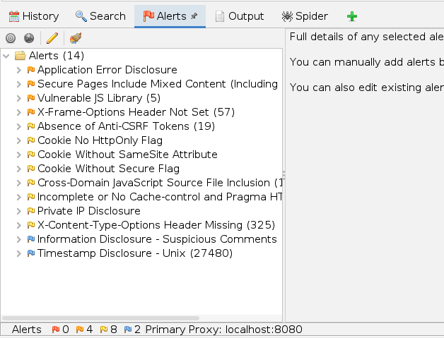

After spider scan is completed, active scan will begin.

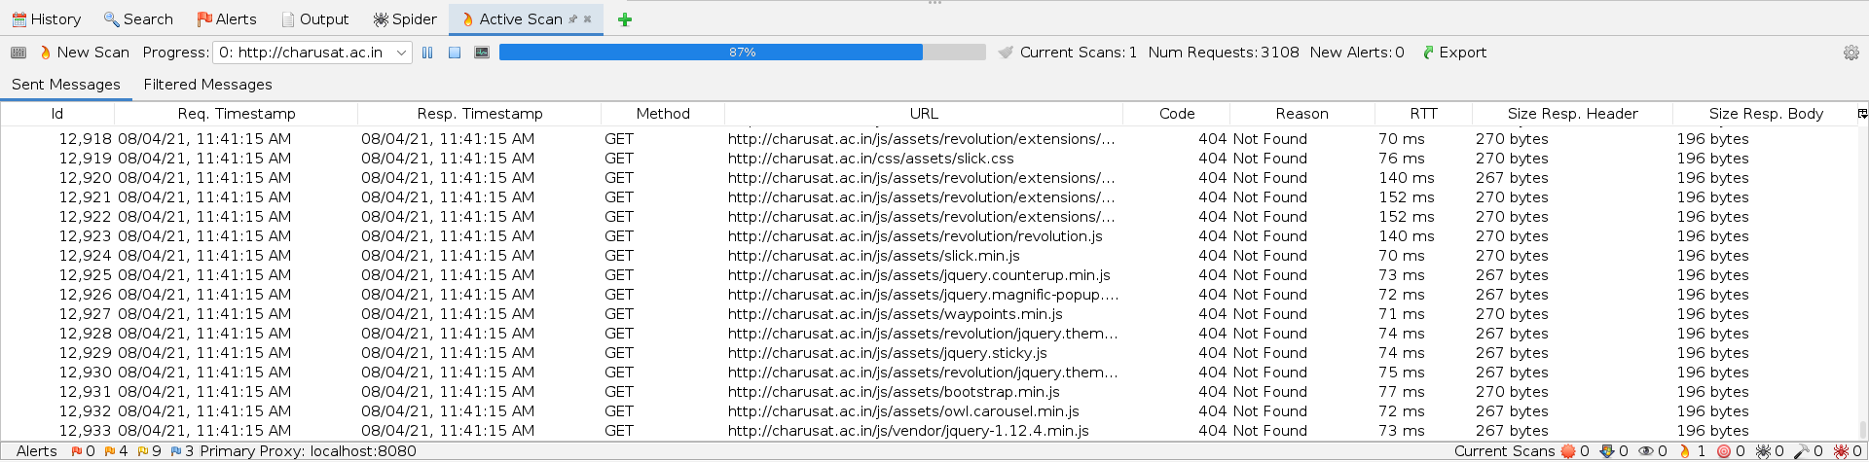

We can also see the content of website of the left side.

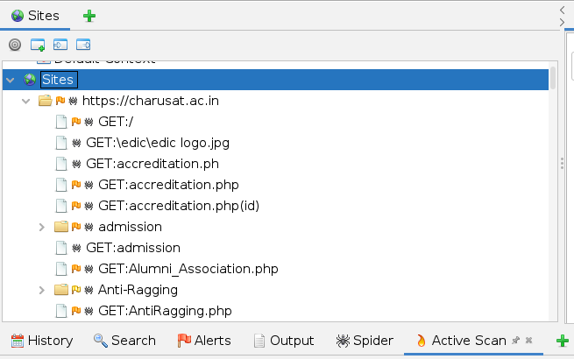

**CONCLUSION:**

In this practical, we used ZAP tool for web analysis. We scanned a website for its contents and alerts.

**PRACTICAL - 9**

**AIM**: Implement GPG for windows.

**TOOL INTRODUCTION:**

**GPG –**

* GnuPG is a complete and free implementation of the OpenPGP standard as defined by RFC4880 (also known as PGP).
* GnuPG allows you to encrypt and sign your data and communications; it features a versatile key management system, along with access modules for all kinds of public key directories.
* GnuPG, also known as GPG, is a command line tool with features for easy integration with other applications.
* A wealth of frontend applications and libraries are available. GnuPG also provides support for S/MIME and Secure Shell (ssh).
* Since its introduction in 1997, GnuPG is Free Software (meaning that it respects your freedom). It can be freely used, modified and distributed under the terms of the GNU General Public License.
* The current version of GnuPG is 2.2.27.
* Gpg4win is a Windows version of GnuPG featuring a context menu tool, a crypto manager, and an Outlook plugin to send and receive standard PGP/MIME mails. The current version of Gpg4win is 3.1.15.

**Kleopatra:**

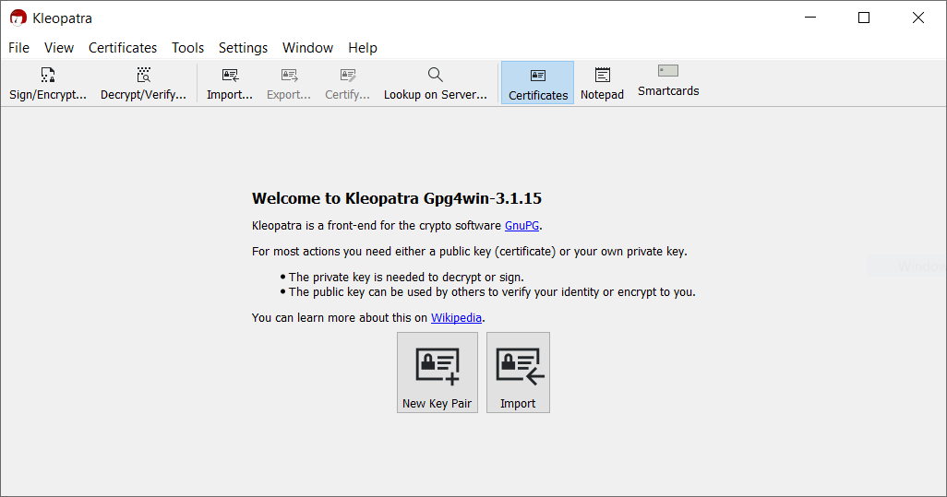

* + First, we will crate a new key pair.

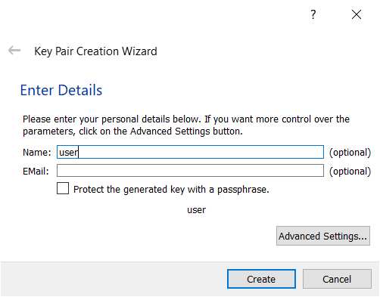

* We will give any name we want and create the key.

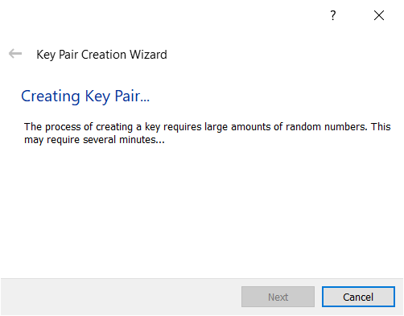

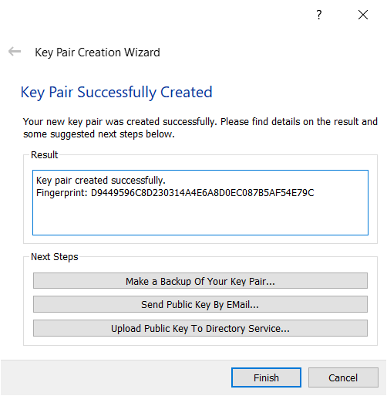

* Then we can encrypt any file using this key pair.
* We have created a file called demo.txt with simple text “Hello world” in it.
* Now we will encrypt it using the key pair we just created.
* We will click on sign/encrypt button on the top.

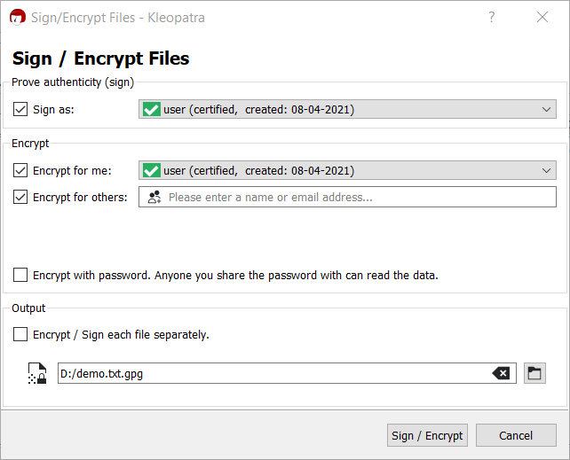

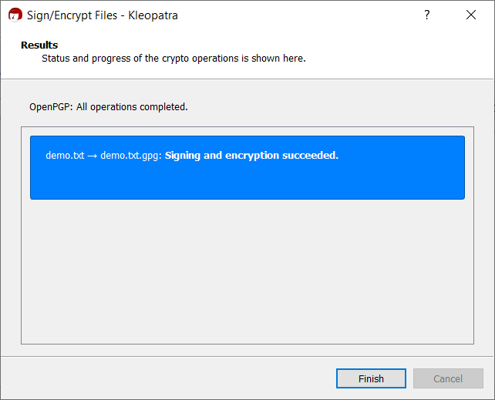

* We can find another file at the location.

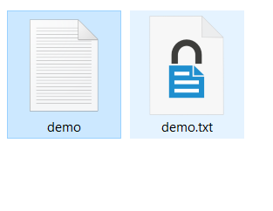

* When we double click on that file, we will see a window.

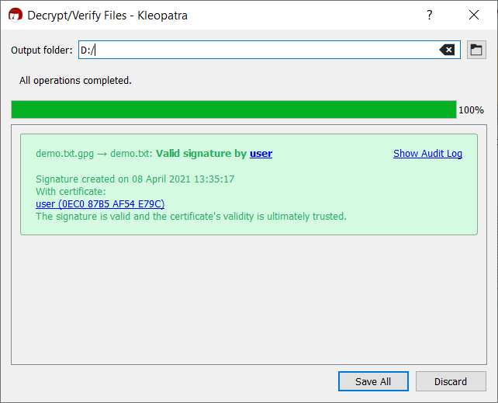

* We can check that we will get our original file back.

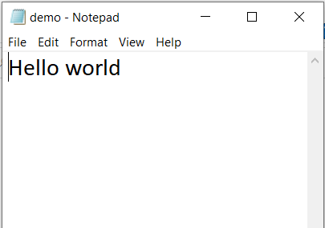

**CONCLUSION:**

In this practical, we learned about GPG and we implemented it in windows. We created a certificate and encrypted a file using it. We also decrypted it using same certificate and verified that our content was recovered.

**PRACTICAL - 10**

**AIM**:

Setup Firewall that

a) Allow all outgoing connection

b) Block all unwanted incoming connection

**TOOL INTRODUCTION:**

**Firewall:**

* A Firewall is a network security device that monitors and filters incoming and outgoing network traffic based on an organization’s previously established security policies.
* At its most basic, a firewall is essentially the barrier that sits between a private internal network and the public Internet.
* A firewall’s main purpose is to allow non-threatening traffic in and to keep dangerous traffic out.
* Firewalls have existed since the late 1980’s and started out as packet filters, which were networks set up to examine packets, or bytes, transferred between computers.
* Though packet filtering firewalls are still in use today, firewalls have come a long way as technology has developed throughout the decades.
* Back in 1993, Check Point CEO Gil Shwed introduced the first stateful inspection firewall, FireWall-1. Fast forward twenty-seven years, and a firewall is still an organization’s first line of defense against cyber attacks.
* A Firewall is a necessary part of any security architecture and takes the guesswork out of host level protections and entrusts them to your network security device.
* Firewalls, and especially Next Generation Firewalls, focus on blocking malware and application-layer attacks, along with an integrated intrusion prevention system (IPS), these Next Generation Firewalls can react quickly and seamlessly to detect and react to outside attacks across the whole network.
* They can set policies to better defend your network and carry out quick assessments to detect invasive or suspicious activity, like malware, and shut it down.

**Firewall:**

We can configure firewall with iptables command.

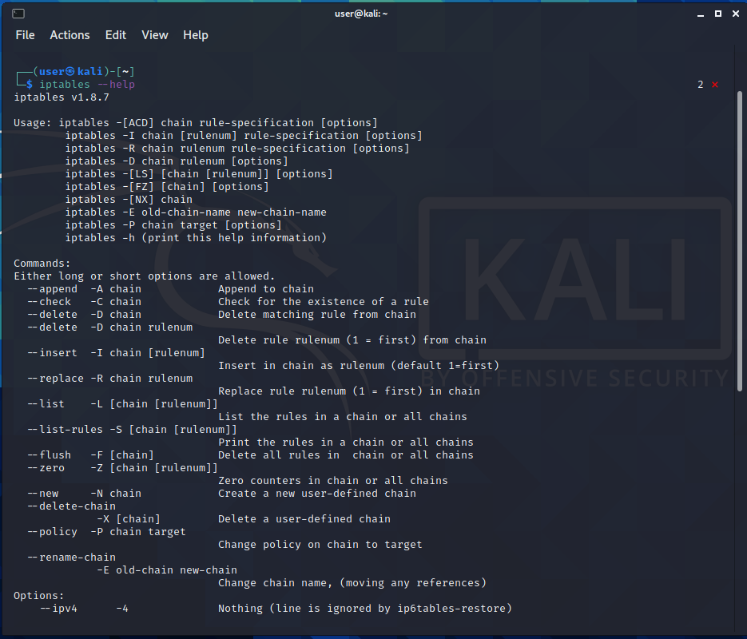

Command: iptables -L -v

We can list the configuration by this command.

It will have 3 queues – input, forward and output.

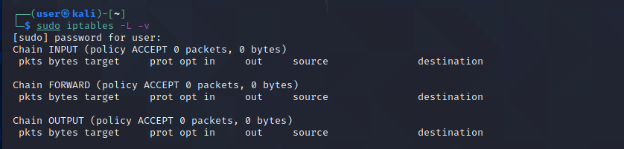

Command: iptables -A INPUT -s 192.168.0.106 -j ACCEPT

This command will tell firewall to accept every packet with source 192.168.0.106.

We can change the IP address as our need.

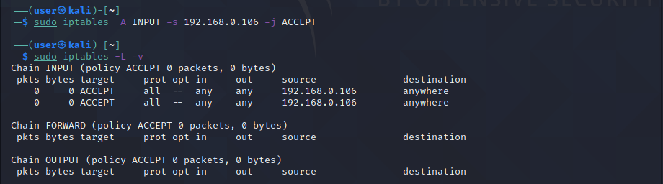

We can configure firewall by protocol and port number too.

Command: iptables -A INPUT -p tcp –dport 80 -j ACCEPT

It will append to the rules of INPUT that any packet with tcp protocol and destination port 80 should be accepted.

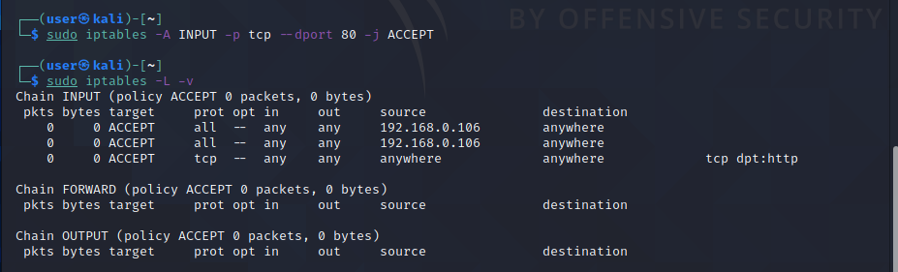

We can use the same command to drop those packets too.

We just need to replace “ACCEPT” to “DROP”.

Command: iptables -A INPUT -p tcp –dport 80 -j DROP

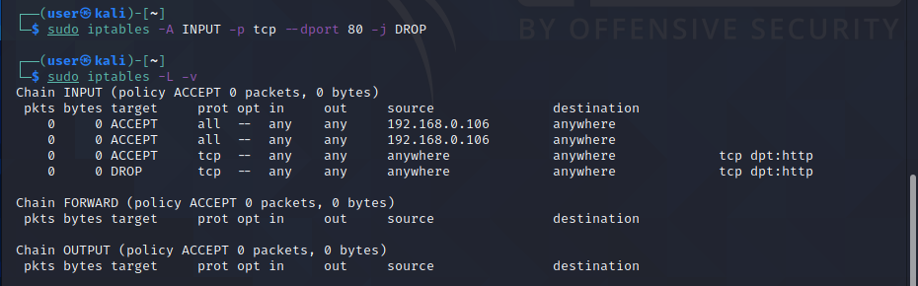

We can also drop packets from certain IP address too.

Command: iptables -A INPUT -s 192.168.0.2 -j DROP

It will drop all the packets with source 192.168.0.2.

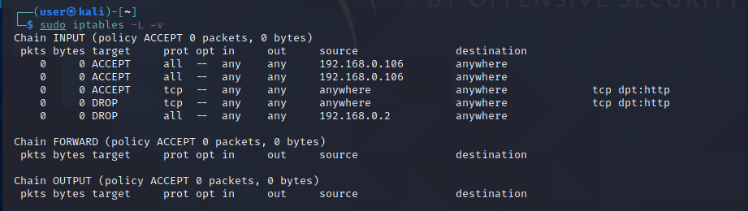

We can stop sending packets to any particular location too.

Command: iptables -A OUTPUT -d 172.217.160.206 -j DROP

It will drop every outgoing packet with destination address as 172.217.160.206.

We can check that packets are not forwarded by ping command.

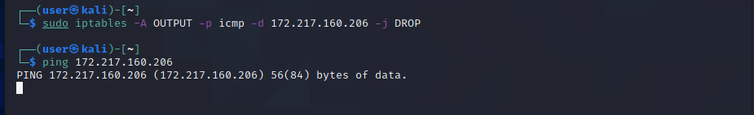

We can clear all entries of iptables too.

Command: iptables -F

We can see that out entries are removed.

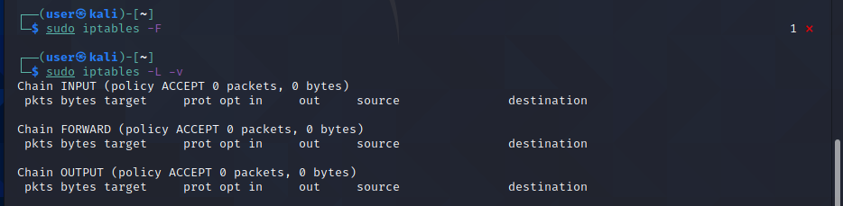

**CONCLUSION:**

In this practical, we learned the command iptables to manually configure firewall and forward and drop the packets according to our need.